

American International University-Bangladesh (AIUB)  
 **Department of Computer Science Faculty of Science & Technology**

**AIUB Lifeline**

A Software Engineering Project Submitted

By

|  |  |  |  |  |
| --- | --- | --- | --- | --- |
| **Semester : Summer 24-25** | | **Section: F** | **Group Number: 05** | |
| **SL** | **Student Name** | **Student ID** | **Contribution (CO3 + CO4)** | Individual Marks |
| 1 | Sheikh Najmul Hossain | 23-51376-1 | 33% |  |
| 2 | Syed Iftear Hasan | 23-51367-1 | 34% |  |
| 3 | Mashrafi Ahsan | 23-51355-1 | 33% |  |
| 4 |  |  |  |  |
| 5 |  |  |  |  |

The project will be evaluated for the following Course Outcomes



|  |  |  |
| --- | --- | --- |
| ***CO3 (PO-g-1)***  ***Select appropriate software engineering models, project management roles and their associated skills for the complex software engineering project and evaluate the sustainability of developed software, taking into consideration the societal and environmental aspects*** | Total Marks | |
|  | |
| Selection of Software Engineering Models: Process model selection and presents sufficient evidence to support argument for the model selection | [5 Marks] |  |
| Role identification and Responsibility Allocation: Well-planned project with proper role identification and responsibility allocation in the project management activities | [5Marks] |  |
| Formatting and Submission: Submission, Defense, Completeness, Spelling, grammar, and Organization of the Project report | [5Marks] |  |
| ***CO4 (PO-k-1)***  ***Apply engineering management principles and economic decision making to develop software engineering project management plan.*** | Total Marks | |
|  | |
| Project WBS and Testcases: Relevant WBS (project task list) and testcases for the proposed project are stated properly. | [5Marks] |  |
| Effort Estimation and Scheduling: Project estimation was described using proper effort estimation or schedules based on available project resources | [5Marks] |  |
| Risk Management: Sufficient and appropriate risks are identified, analyzed, and properly categorized or prioritized. | [5Marks] |  |

**1. PROJECT PROPOSAL**



## Background to the Problem

For most students, university life comes with a lot of pressure such as classes, exams, future planning, and everyday responsibilities all at once. Students are required to manage academic responsibilities, navigate course materials, give examinations, maintain social relationships, and plan for their future all while dealing with personal and real-life challenges. As one of the leading private universities in Bangladesh, AIUB hosts a diverse and dynamic student body that frequently experiences these pressures.

In this context, students face many problems that are not academic issues. These factors include consideration that students are not able to locate lost belongings on campus, they cannot easily find consistent lecture/handwritten notes, they are unaware of the faculty's consulting hours, and there is no go-to space for academic related questions and accessibility of faculty provided materials. Today, students are using informal channels like Facebook groups, WhatsApp chats and word of mouth to serve their needs. They generally work and, typically, lack responsible moderation, and they unaccountably fail to deliver uniform access or good information to all students. The problem exists as there is no unified, organized platform exclusively centered for the AIUB students. It can cause additional stress, miscommunication, and missed opportunities for academic and other forms of personal support. That’s why we think it’s time for a clean digital solution that aggregates the core student support services into a user-friendly system.

## Solution to the Problem and Process Model Selection

**Importance of the Problem:**

Because of the following issues, students waste a lot of valuable time searching for important resources and a lot of times end up with wrong and outdated materials. Students also find it difficult to navigate their lost belongings from home. This platform will solve a lot of problems which in turn will benefit the stakeholders of the university.

**Project Objective:**

In this technology driven age, not having a single modern platform at a leading private university such as AIUB is conspicuous. Plugging this gap is an opportunity to establish a new and modern platform that can enhance academic achievement along with student life in general.

By introducing this platform, the university will truly transform into a modern university justifying the leading university of Bangladesh tag and going on to achieve more great achievements in the future.

Our goal is to build one easy-to-use app that brings together everything students and teachers need in one place:

* Enhancing academic collaboration,
* Reducing communication gaps,
* Seamlessly access essential latest materials and schedules,
* Promoting a supportive campus ecosystem.

**Proposed Solution:**

We propose “AIUB Lifeline”, a web application which will have the following features:

Basic Functionalities of the Proposed Solution:

1. **Lost and Found:** Students will be able to report and search for missing personal belongings through a secure and centralized platform. The platform will have options to upload images and provide detailed time and place of the item so that it would be easier to locate the missing belonging.
2. **Sharing Lecture and Handwritten Notes:** Through this platform the students will be able to upload and search for handwritten notes as well as lecture notes. Students will be able to search the notes by sorting them by course code, instructor, course name and department.
3. **Authorized Material Approved by Faculty:** Authorized scholarly material such as class notes, tutorial sheets, question papers, and practice sets shall be provided by the faculty to the students. There will be fewer unauthorized uses of sources and higher content accuracy.
4. **Faculty TSF Section:** There will be a designated section showing the available consulting times of every one of the faculty members. This will make it easy for students to schedule appointments, clear their questions, or receive study help efficiently.
5. **Q&A Platform:** There will be an academically moderated discussion forum where students will be able to post academic questions, receive answers from peers or instructors, and up vote useful responses. Questions will be labeled by subject, course, or topic for easier discovery and searching.

**Target Group & Benefits:**

**Target Users:**

* **Primary:** undergraduate & graduate students.
* **Secondary:** Faculty members.

**Benefits:**

* Students will be able to manage their time in a better way which will help them academically.
* Teachers will be able to save a lot of class time by just providing the platform and students will be able to collect everything from that platform such as faculty TSF, latest lecture notes, handwritten notes etc.
* University can manage its online services at an organized and planned manner which will reduce cost and time.

**Feasibility & Appropriateness:**

* It falls squarely within the purview of the Software Development Life Cycle (SDLC) as it encompasses system planning, design, documentation, and evaluation. Code implementation isn't required here.
* It addresses problematically defined problems by customized features designed specifically for AIUB student’s purposes, rather than giving universal solutions.
* If the system is effective at AIUB, it can be easily modified for other universities that also experience the same issues. That makes it not only beneficial now but also a sustainable and flexible solution.

**Selected Software Development Process Model:**

The chosen process model for this project is **Scrum**. Scrum is an agile framework that focuses on iterative development, adaptability, and continuous feedback. It is particularly well-suited for projects where some requirements are clear while others evolve over time, which matches the nature of **AIUB Lifeline**.

**Analysis of the Project Environment:**

The environment of this project is a mixed environment. Some of the requirements like Lost & Found and Faculty TSF are well understood and relatively static. Other details such as the layout of the Q&A tool or how the notes will be sorted will also be subject to change on the back of user feedback. This makes Scrum a good fit, because it will make the platform stable by regular sprint reviews and backlog refinements.

**Team Size, Communication & Feasibility:**

Scrum is ideal for small, cross-functional teams, which is the project’s smallest possible scale. It roles out a clear separation of concerns (Product Owner, Scrum Master, and Development Team) as well as accountability and focus. We have daily stand-ups, and sprint reviews, which all but ensures that communication is clear. The incremental release of increments is what makes the project viable to meet its goal of having functional system within a reasonable timeline.

**Flexibility of the Model:**

Scrum is a real adaptive framework and that is one of its greatest strengths. Backlog prioritizations can be shifted should the project scope increase. If there are new technologies that come out, you can refactor architecture in future sprint. If suggested changes are indicated through student input, we can make these without the flow of development being disrupted. This will allow the project to be completed on time.

**Contribution to Scientific Results:**

The project contributes to Software Engineering by recording how a lean approach can be used to address real world student support problems. The documentation of the project’s requirements, backlog prioritization, sprint results, and feedback loops would be useful for further studies and case studies in the context of academic technological solutions.

**Evidence Supporting Model Selection:**

Scrum is chosen because:

* It allows incremental progress that students and faculty can test early.
* It thrives in environments where not all requirements are fixed from the start.
* It emphasizes collaboration between stakeholders, which is essential in a university setting.
* It reduces the risk of delivering an incomplete or unusable product.

**Risk & Uncertainty Management:**

Scrum minimizes risks by iterating constantly. In sprint planning a lot of the risks can be called out, In daily standup there will be a discussion session about the risk and then the areas will be reviewed where there might be risks. Rather than save problems until the end, Scrum raises concerns that arise early, which helps reduce the risk of project failure.

**Alignment with Project Schedule:**

Scrum breaks the work into periods, called sprints (usually 2–4 weeks). In every sprint we deliver a feature which can be measured constantly. It also guarantees the feature to be delivered on time and that deadlines are more reachable, since the project is divided into smaller digestible pieces.

**Justification of the Chosen Model:**

Scrum is much more appropriate compared to Waterfall, XP or any other model. Scrum is not a traditional model such as Waterfall which expects the requirement not to be revisited after it is

complete wherever in Scrum, changes are inevitable. XP is not suited because it needs a strict environment where stakeholders such as students and faculty members always need to be available, which will not be possible for this platform.

Scrum strikes as the right fit because it has a practical structure which ensures all the stakeholders actively engage with the platform without disrupting the projects flow.   
This makes it the most suitable model for developing **AIUB Lifeline**.

|  |  |  |  |
| --- | --- | --- | --- |
| **Phase** | **Item No** | **Specification [Role]** | **User Story** |
| **Feature: 1** | | **Header** |  |
| phase 1 | 1 | Header | As a user, I want to easily navigate the platform from a clear and consistent header so that I can access different sections without confusion. |
| **Feature: 2** | | **Footer** |  |
| phase 1 | 2 | Footer | As a user, I want the footer to provide quick and organized access to important sections of the platform so that I can easily find what I need without having to navigate back to the top of the page. The footer should allow students to reach key features like login, sign up, lost and found, notes, and the Q&A platform directly from any page. It should also give visitors a simple way to find support resources such as the blog, policies, and knowledgebase, while displaying accurate contact information and social media links so they can connect with the platform easily. |
| **Feature: 3** | | **Home Page** |  |
| phase 1 | 3 | Hero Section | As a student or teacher visiting the platform, I want the homepage to immediately explain that AIUB Lifeline is a student support platform so I can understand its purpose and decide where to go next. The hero section should highlight how the platform helps by organizing lecture materials, lost and found, and faculty TFS in one place. It should also provide clear call-to-action buttons so that I can quickly choose whether to explore more about the platform, access student-specific resources, or connect as a teacher. |
| phase 2 | 4 | Quick Navigation Hub | As a student or faculty member visiting the homepage, I want quick navigation suggestions displayed in one place so that I can easily choose from the most relevant actions, such as logging in, searching for lecture materials, or finding faculty information, without having to browse multiple menus. This helps me save time and directly access the resources I need. |
| phase 3 | 5 | Newsletter Subscription | As a visitor, I want an easy way to subscribe to the AIUB Lifeline newsletter so that I can receive updates, announcements, and important information directly in my email without having to revisit the website frequently. |
| **Feature: 4** | | **Login Page** |  |
| phase 1 | 6 | Login Page [student][faculty][admin] | As a student, faculty member or admin, I want to securely log in to AIUB Lifeline using my registered email and password so that I can access my personal dashboard, resources, and academic tools. |
| **Feature: 5** | | **Registration Page** |  |
| phase 1 | 7 | Registration Page[student][faculty][admin] | As a student faculty of admin, I want to register with my name, student ID, email, and password so that I can create a personal account on AIUB Lifeline and gain access to features like lecture materials, lost & found, handwritten notes, and Q&A. |
| **Feature: 6** | | **Password Reset** |  |
| phase 1 | 8 | Password Reset [student][faculty][admin] | As a student, faculty member or admin, I want to reset my password via email or Google sign-in so I can regain access to my account. |
| **Feature: 7** | | **Student Dashboard** |  |
| phase 1 | 9 | Student Dashboard [student] | As a student, I want a personalized dashboard where I can quickly access all the tools and resources I need, such as lecture materials, handwritten notes, faculty TFS, Q&A platform, lost & found, and announcements. Having everything in one place allows me to stay organized, save time, and manage my academic activities more effectively. |
| phase 2 | 10 | Chatbox [student] | As a student, I want a simple chatbox to message classmates and faculty so I can get quick help and coordinate tasks. |
| phase 3 | 11 | Edit Profile [student] | As a student or faculty member, I want to update my profile details (name, ID, phone, password, and email) so my account remains accurate and secure. |
| **Feature: 8** | | **Faculty Dashboard** |  |
| phase 1 | 12 | Faculty Dashboard [faculty] | As a faculty member, I want a centralized dashboard where I can upload lecture materials, manage TFS schedules, respond to student queries, post announcements, and review submitted notes so that I can efficiently support students and stay connected with their academic needs. |
| phase 2 | 13 | Chatbox [faculty] | As a faculty, I want a simple chatbox to message classmates and faculty so I can get quick help and coordinate tasks. |
| phase 3 | 14 | Edit Profile [faculty] | As a faculty member, I want to update my profile details (name, ID, phone, password, and email) so my account remains accurate and secure. |
| **Feature: 9** | | **Admin Dashboard** |  |
| phase 1 | 15 | Admin Dashboard [admin] | As an admin, I want a centralized dashboard where I can manage students, faculty, access permissions, and platform-wide resources so that I can ensure the system is functioning correctly, content is monitored, and both students and faculty receive the support they need. |
| phase 2 | 16 | Edit Profile [admin] | As a admin member, I want to update my profile details (name, ID, phone, password, and email) so my account remains accurate and secure. |
| **Feature: 10** | | **Lost and Found** |  |
| phase 1 | 17 | Lost and Found Area [student][faculty][admin] | As a student or faculty member, I want to report lost or found items and search through listings so that I can recover my belongings or help others retrieve theirs. As an admin, I want to review and moderate all lost and found reports so that the platform remains reliable, organized, and free from misuse. |
| phase 2 | 18 | Post About A Lost Item [student][faculty][admin] | As a student or faculty member, I want to post details about a lost item (including location, name, description, and optional image) so that others can identify and help me recover it. |
| **Feature: 11** | | **Lecture Materials And Notes** |  |
| phase 1 | 19 | Lecture Metarial And Notes Area [student][faculty][admin] | As a student, I want to download lecture materials and handwritten notes so that I can study effectively and prepare for exams. As a faculty member, I want to upload lecture files and share study materials so that students have easy access to official course resources. As an admin, I want to oversee uploaded content so that all materials and notes meet platform guidelines and are well-organized. |
| phase 2 | 20 | Lecture Metarial And Notes Open [student][faculty][admin] | As a student, I want to upload, view, and access shared lecture notes and study materials so that I can prepare better for exams and assignments. and upload notes. As a faculty member, I want to upload official lecture material to support students. As an admin, I want to review uploads, ensure they are relevant, and manage inappropriate or duplicate content. |
| phase 3 | 21 | Lecture Metarial And Notes Post [student][faculty] | As a student or faculty member, I want to upload and share notes/materials (course name, title, description, and optional image) so others can access and benefit from them. |
| **Feature: 12** | | **Faculty TFS Search** |  |
| phase 1 | 22 | Faculty TFS Search [student][faculty][admin] | As a student, I want to search for faculty availability (TFS) so that I can meet them during office hours or contact them when needed. As a faculty member, I want to update and manage my own availability so students can see when and where they can reach me. As an admin, I want to review, approve, and edit faculty schedules to ensure accuracy and consistency across the system. |
| **Feature: 13** | | **Q&A Area** |  |
| phase 1 | 23 | Q&A Area [student][faculty][admin] | As a student, I want to ask academic questions and receive answers from peers or faculty so that I can better understand my course materials. As a faculty member, I want to answer student questions and provide academic guidance so that I can support learning beyond the classroom. As an admin, I want to monitor and moderate the Q&A area so that discussions remain respectful, accurate, and relevant. |
| phase 2 | 24 | Q&A View [student][faculty][admin] | As a student, I want to ask questions about academic or technical topics so I can get help from peers and faculty. As a faculty member, I want to answer questions and provide verified guidance to students. As an admin, I want to moderate questions and answers to keep the platform relevant and respectful. |
| phase 3 | 25 | Q&A Post [student][faculty] | As a student or faculty member, I want to post questions with tags, title, and details so others can answer and discuss. |
| **Feature: 14** | | **Blogs** |  |
| phase 1 | 26 | Blogs [student][faculty][admin] | Student/Faculty: I want to read blog posts and updates so I can stay informed about announcements, events, and resources.  Admin: I want to create, edit, and remove blog posts so I can manage platform updates effectively. |
| phase 2 | 27 | Blog Detailed Page [student][faculty][admin] | Student/Faculty: I want to read the full blog post with details, images, and references so I can gain full knowledge from it.  Admin: I want to edit or delete blog posts so I can manage blog content effectively. |
| **Feature: 15** | | **About Page** |  |
| phase 1 | 28 | About Page [student][faculty][admin] | As a visitor, I want to read about AIUB Lifeline’s mission, vision, and features so that I can understand what the platform is, why it exists, and how it can help me as a student or faculty member. |
| **Feature: 16** | | **Support Page** |  |
| phase 1 | 29 | Contact Us [student][faculty][admin] | As a user, I want a support page where I can access FAQs, guides, policies, and contact options so that I can resolve issues or learn how to use the platform effectively. |
| **Feature: 17** | | **Legal Section** |  |
| phase 1 | 30 | Terms and Conditions [student][faculty][admin] | As a user, I want to read the Terms & Conditions so that I understand my responsibilities, the rules of using AIUB Lifeline, and the limitations of the platform. |
| phase 2 | 31 | Privacy Policy [student][faculty][admin] | As a user, I want to read the Privacy Policy so that I understand what data is collected, how it is used, and what rights I have to manage my information. |
| **Feature: 18** | | **Non-Functional Requirement** |  |
| phase 1 | 32 | Performance[student][faculty][admin] | As a student, faculty and admin, I want pages and actions to feel instant so I can complete tasks without waiting. |
| phase 2 | 33 | Security [student][faculty][admin] | As a student, faculty and admin, I want my account and data protected so only the right people can access the right tools. |
| phase 3 | 34 | Usability [student][faculty][admin] | As a visitor, I want consistent navigation on every page so I never feel lost. |
| phrase 4 | 35 | Reliability [student][faculty][admin] | As a student, faculty and admin, I want accurate, dependable information so I can trust what I see. |
| phrase 5 | 36 | Scalability [admin] | As a admin, I want the system to grow with usage and be adaptable to other universities. |
| phrase 6 | 37 | Maintainability [admin] | As a admin, I want the codebase to be easy to modify so we can iterate every sprint. |

# 1.3 Project Role Identification and Responsibilities

**Main Roles Involved:**

* **Product Owner**: Oversees the vision of the project, prioritizes the backlog, and represents stakeholder interests.
* **Scrum Master**: Facilitates Scrum ceremonies, removes obstacles for the team, and ensures that the Scrum framework is followed.
* **Development Team**: A cross-functional group of designers, developers, and testers responsible for delivering increments of the product.

**Responsibilities in Key Stages:**

* **Requirements Gathering**: The Product Owner leads this phase by engaging with students, faculty, and other stakeholders to document needs, while the Scrum Master ensures smooth communication. The Development Team assists by analyzing technical feasibility.
* **Design**: The Development Team takes primary responsibility for wireframes, system architecture, and UI design. The Product Owner reviews and approves based on alignment with user needs.
* **Implementation**: Developers within the team write and integrate code, supported by designers for interface elements. The Scrum Master ensures that impediments are resolved quickly.
* **Testing**: QA members of the Development Team verify each increment through functional testing and user acceptance testing. Feedback is collected from stakeholders for improvements.
* **Deployment**: The Development Team ensures the system is deployed smoothly. The Product Owner confirms release readiness, and the Scrum Master coordinates retrospective feedback.

**Distribution and Justification**  
Responsibilities are distributed according to expertise to ensure efficiency:

* The **Product Owner**, with strong communication and organizational skills, focuses on aligning the platform with student and faculty needs.
* The **Scrum Master**, experienced in agile processes, ensures discipline in following Scrum and maintaining momentum.
* The **Development Team**, comprised of members skilled in web development, database management, UI/UX design, and quality assurance, collaboratively handle design, implementation, and testing.

This allocation ensures that each phase of the project is handled by individuals best suited for the role, leveraging their skills while maintaining accountability. It provides a balanced structure where management and technical aspects are both equally prioritized, thereby maximizing the probability of successful project delivery.

## 2. PRODUCT REQUIREMENTS DOCUMENT (PRD)

## 2.1 Functional Requirements































# 3. PROJECT ESTIMATION AND SCHEDULING

## 3.1 Effort and Cost Estimation

Modules in MVP: Lost & Found, Notes Sharing, Authorized Materials, Faculty TSF, Q&A; small web app with CRUD, search/filter, upload (images/PDFs), authentication, and role-based access.

**Using Lines of Code (LOC) estimation:**

**Assumptions:**

* Estimated size SLOC = 15,000
* Team productivity = 500 LOC / PM
* 1 PM = 160 hours
* Cost rate = BDT 45,000 / PM

**Calculations:**

1. Effort (PM) = SLOC / productivity

= 15,000 ÷ 500 = 30.0 PM

1. Effort (hours) = Effort (PM) × 160 hours/PM

= 30.0 × 160 = 4,800 hours

1. Cost = Effort (PM) × Cost rate

= 30.0 × 45,000 = 1,350,000 BDT

**Using COCOMO Model:**

**Assumptions:**

* Project type: Organic (small team, familiar technology)
* Use basic COCOMO coefficients for Organic:
  + a=2.4
  + p=1.05
  + T=0.38
* SLOC = 15,000
* Cost rate = BDT 45,000 / PM

**Calculations:**

Effort = PM = $a×($ SLOC/1000)^P

$=2.4×{(\frac{15000}{1000})}^{1.05}= 41.224$ person-months

Development time = DM = 2.50*(PM)^T

$=2.50 ×{(41.224)}^{0.38}$ = 10.27 months

Required number of people = ST = PM/DM = $\frac{41.224}{10.27}$ = 4.014 ≈ 4 person

## 3.2 Project Scheduling

**Effort Allocation:**

* **Analysis & Design =** 41.224*0.4 =16.4896person-months
* **Coding/Implementation =** 41.224*0.2 =8.2248person-months
* **Testing & Release =** 41.224*0.4 =16.4896person-months

**Earned Value Analysis (EVA):**

Total Tasks = 55, BAC = 41.224*30 = 1240 person-days

|  |  |  |
| --- | --- | --- |
| Task | Planned Effort | Actual Effort |
| 1 | 15 | 16 |
| 2 | 21 | 20 |
| 3 | 14 | 15 |
| 4 | 16 | 15.5 |
| 5 | 24 | 21 |
| 6 | 13 | 15 |
| 7 | 9 | 10 |
| 8 | 16 | 15.5 |
| 9 | 12 | 12 |
| 10 | 18 | 17 |
| 11 | 25 | 23 |
| 12 | 27 | 25 |
| 13 | 10 | - |
| 14 | 20 | - |
| 15 | 15 | - |

BCWP = 210, BCWS = 255, ACWP = 205

SPI = BCWP/ BCWS = 210/255 = 0.8235

SV = BCWP – BCWS = 210 – 255 = - 45 person-day

CPI = BCWP/ ACWP = 210/205 = 1.035

CV = BCWP – ACWP = 210 -205 = 5 person-day

schedule for completion = BCWS/ BAC = 255/1240 = 20.56%

complete = BCWP/ BAC = 210/1240 = 16.93%

**Gantt Chart:**

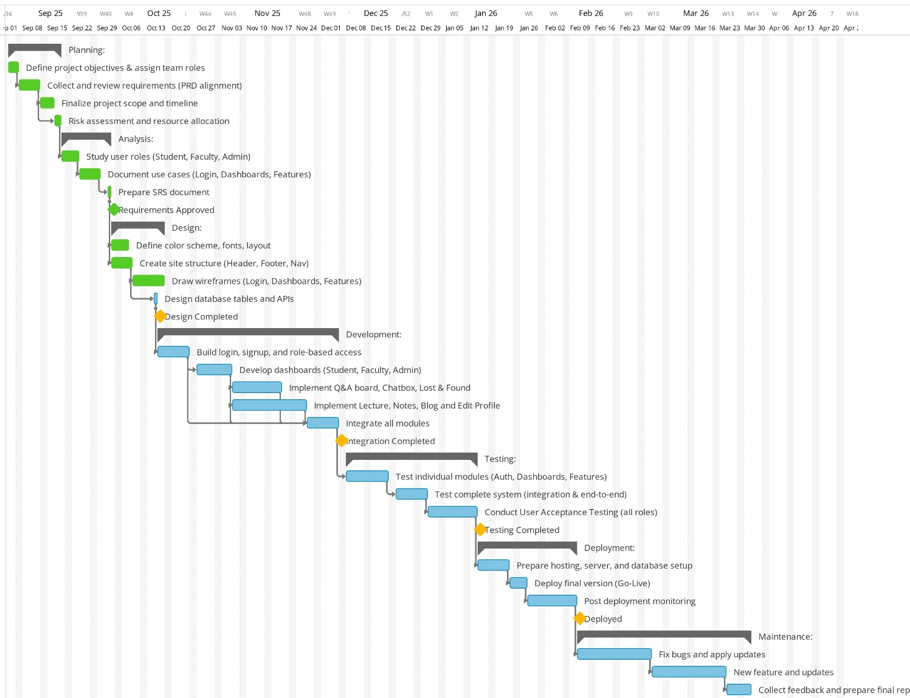

**Work Breakdown Structure:**

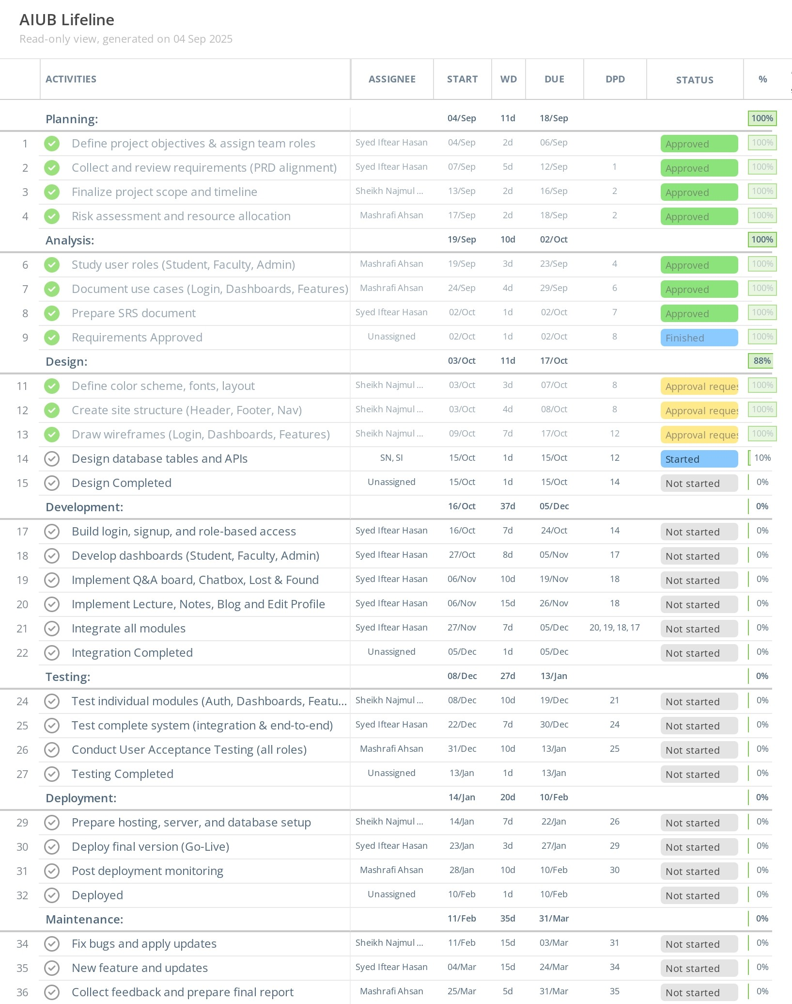

**Trello:**

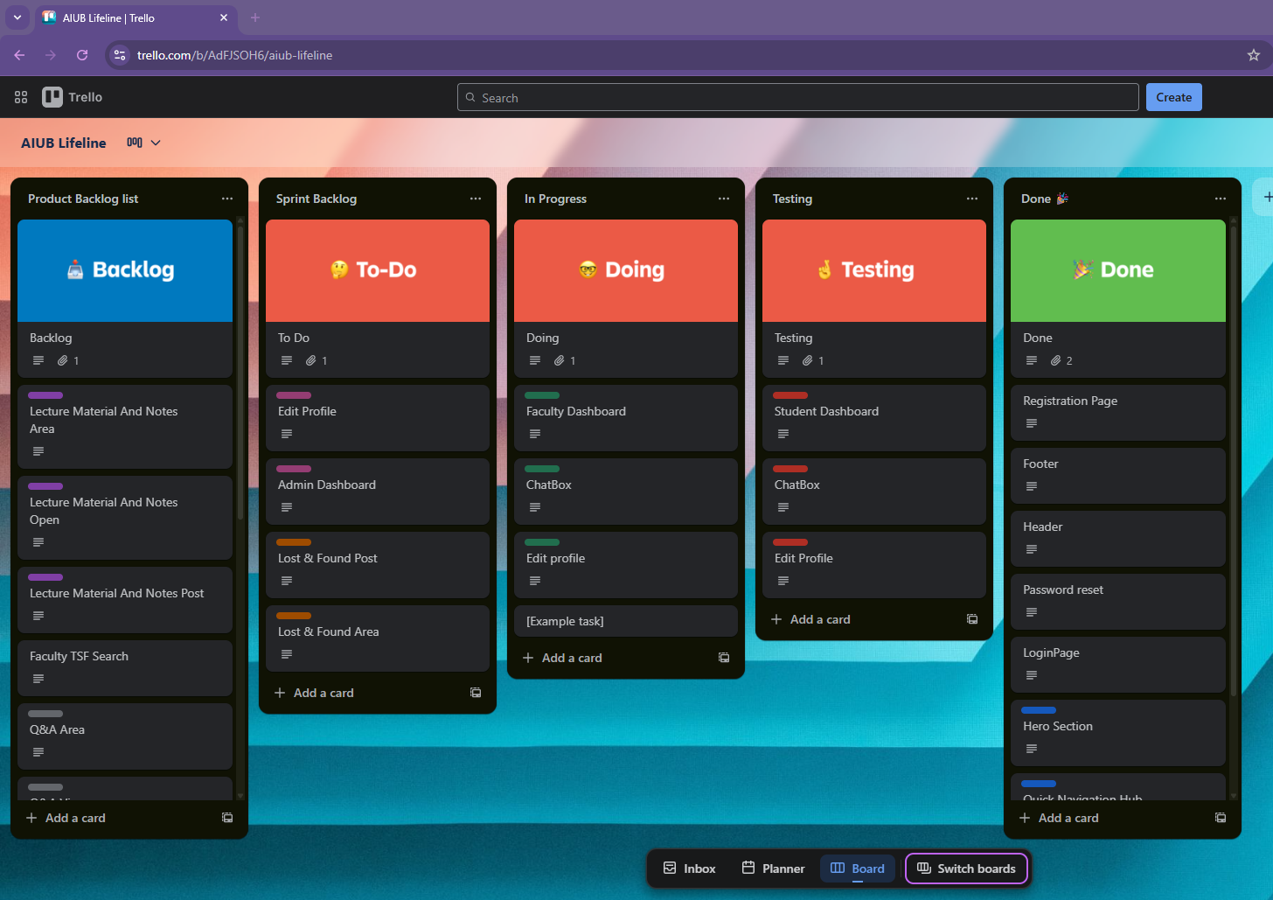

# SOFTWARE DESIGN

**4.1 System Design:**

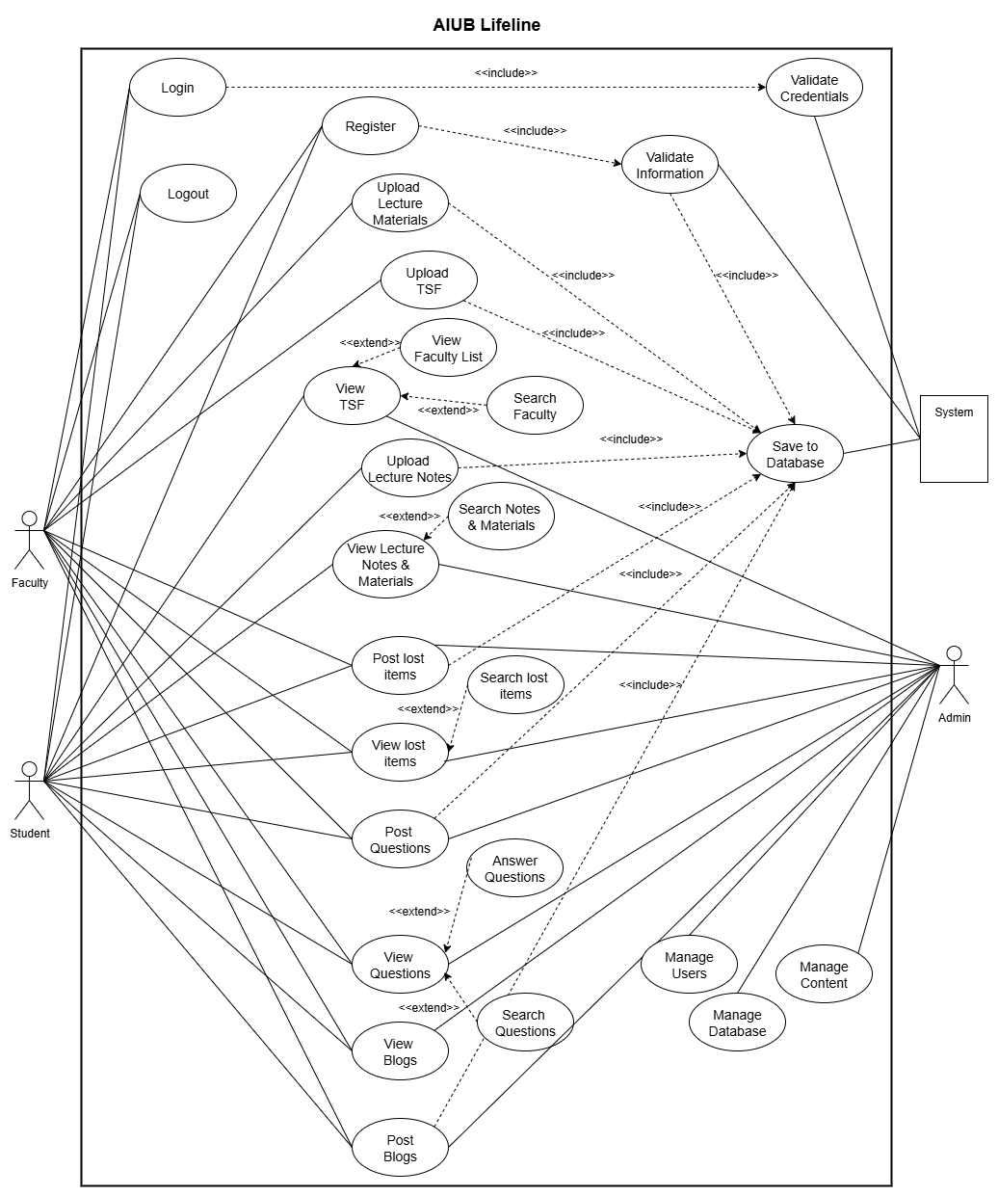

**Use Case Diagram**

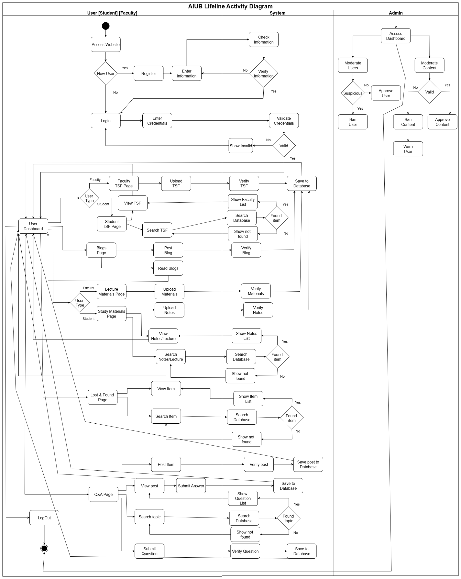

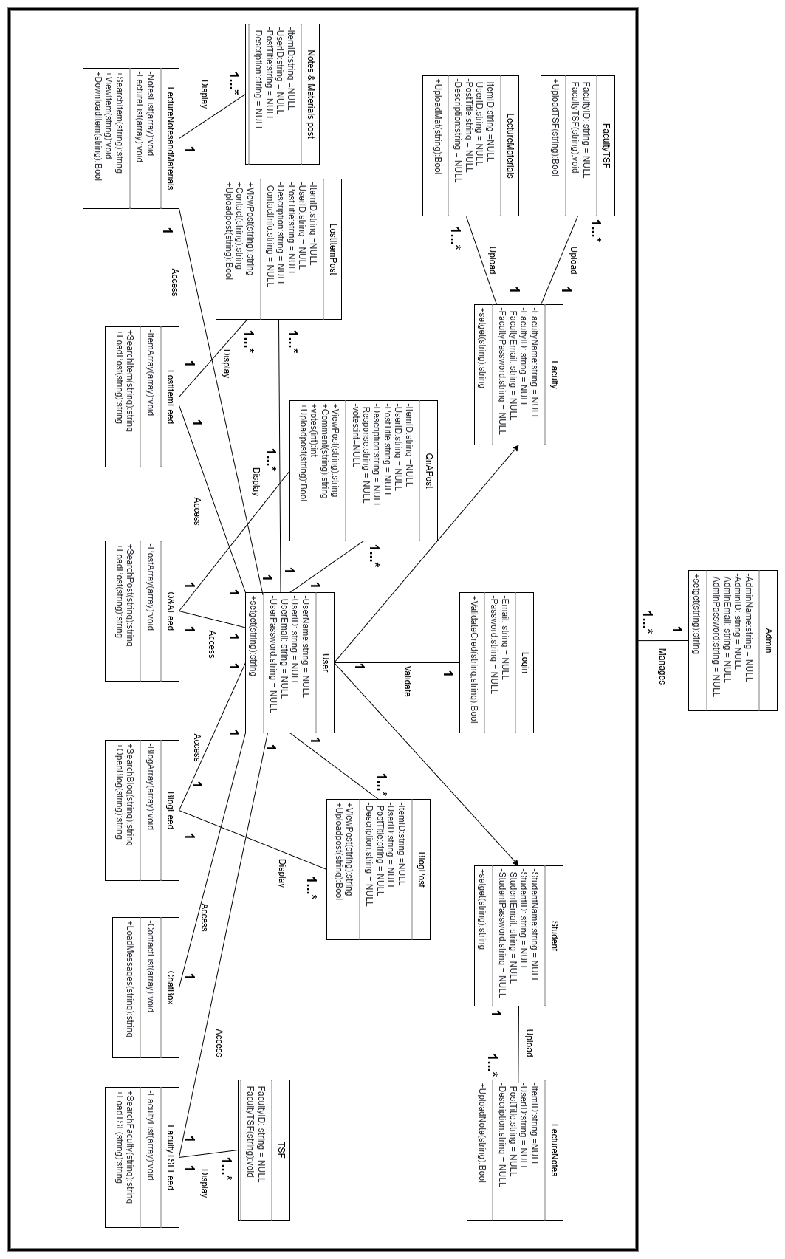  
**Class Diagram**

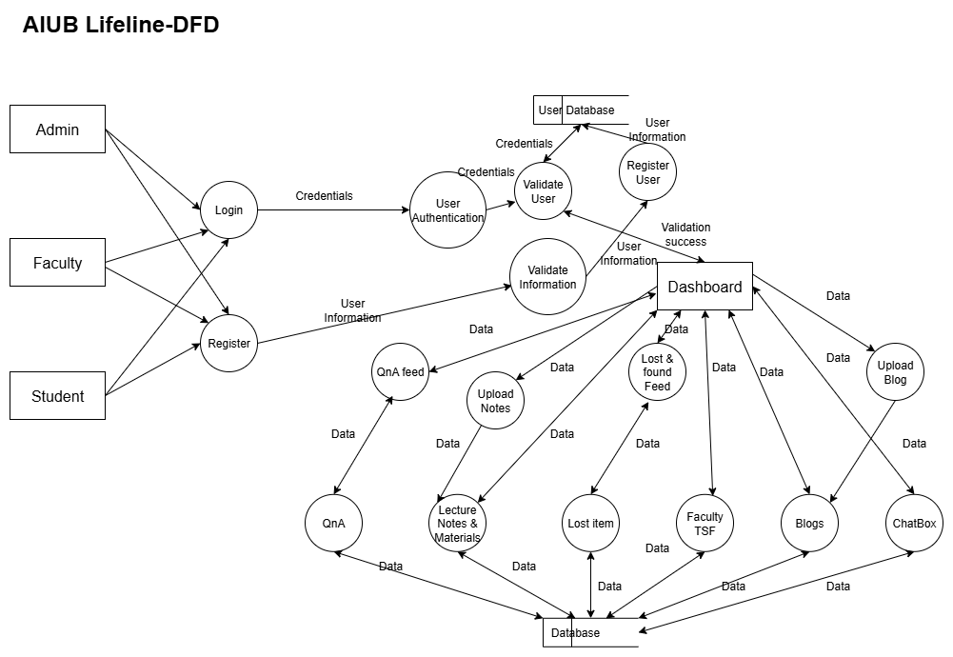

## UI Design using Figma

**UI Design**

AIUB Lifeline- Homepage  
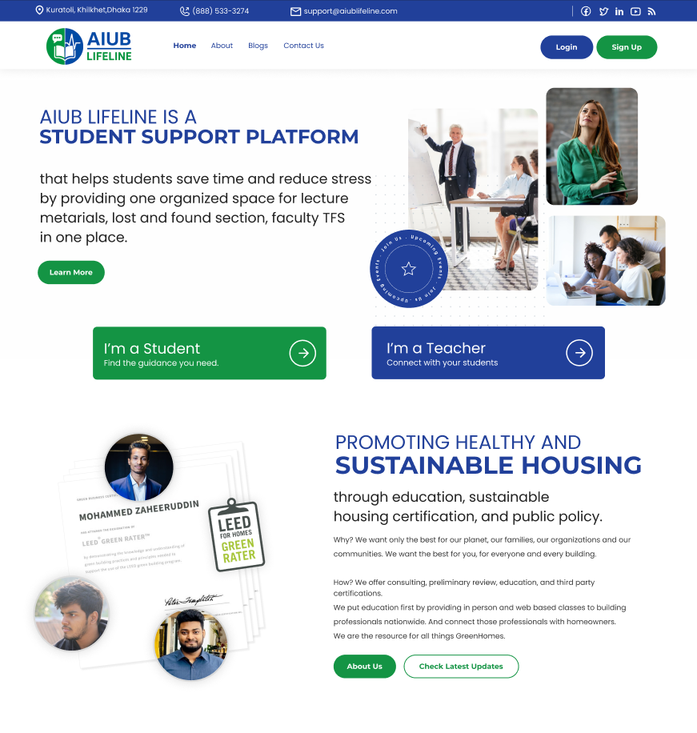

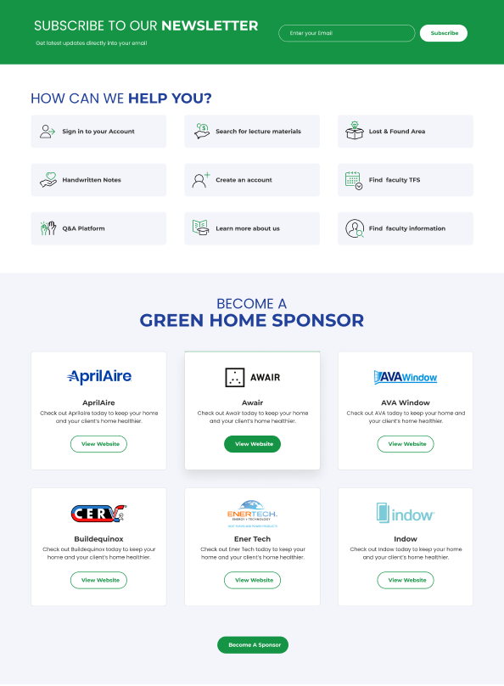

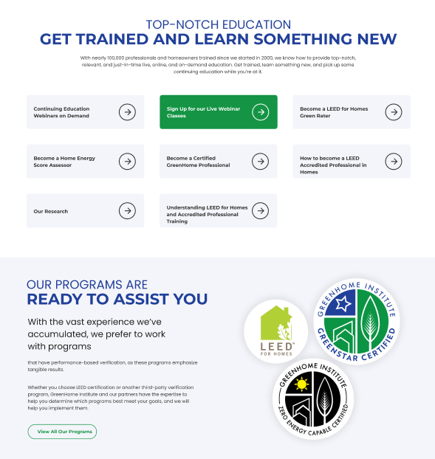

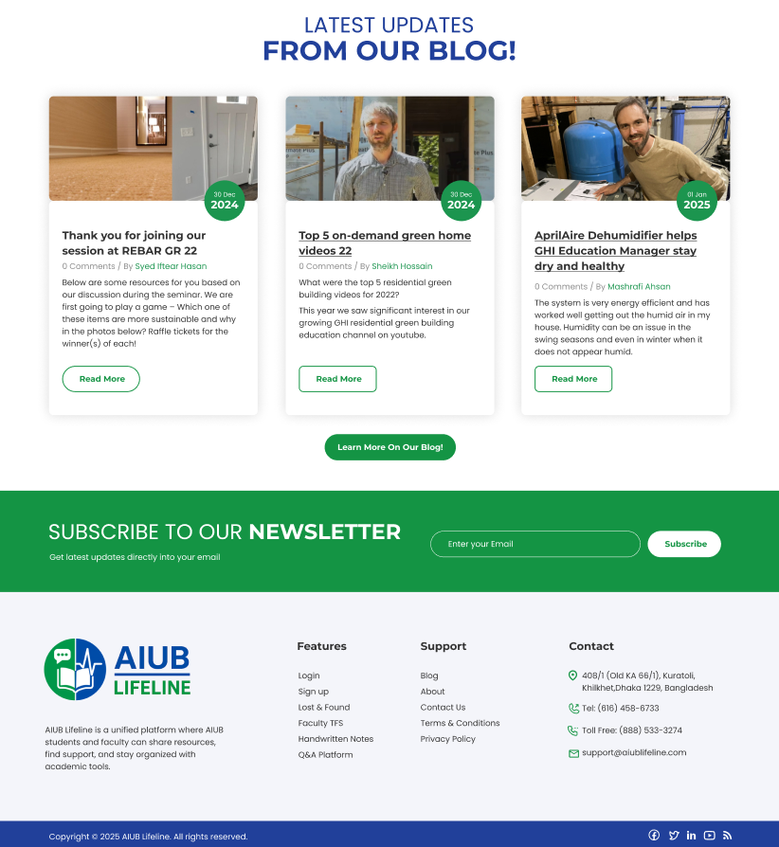

**AIUB Lifeline- Login Page**

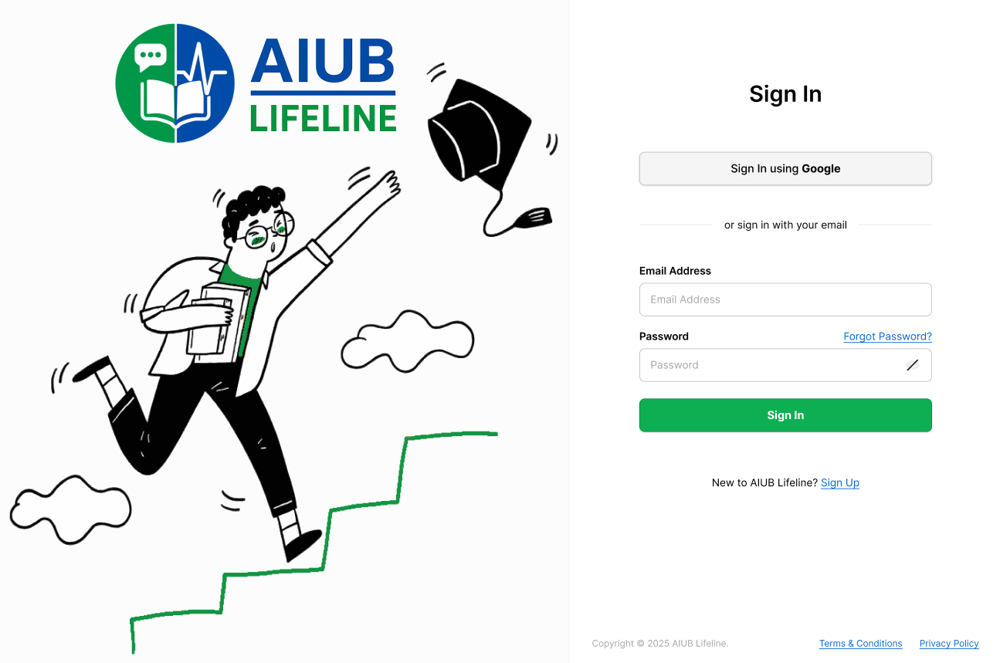

**AIUB Lifeline- Registration Page**  
  
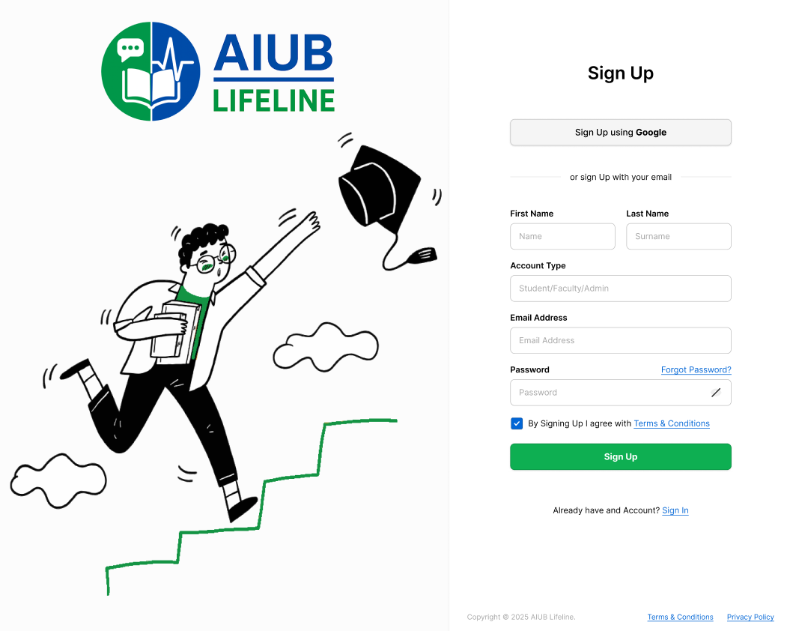

**AIUB Lifeline- Password Reset**

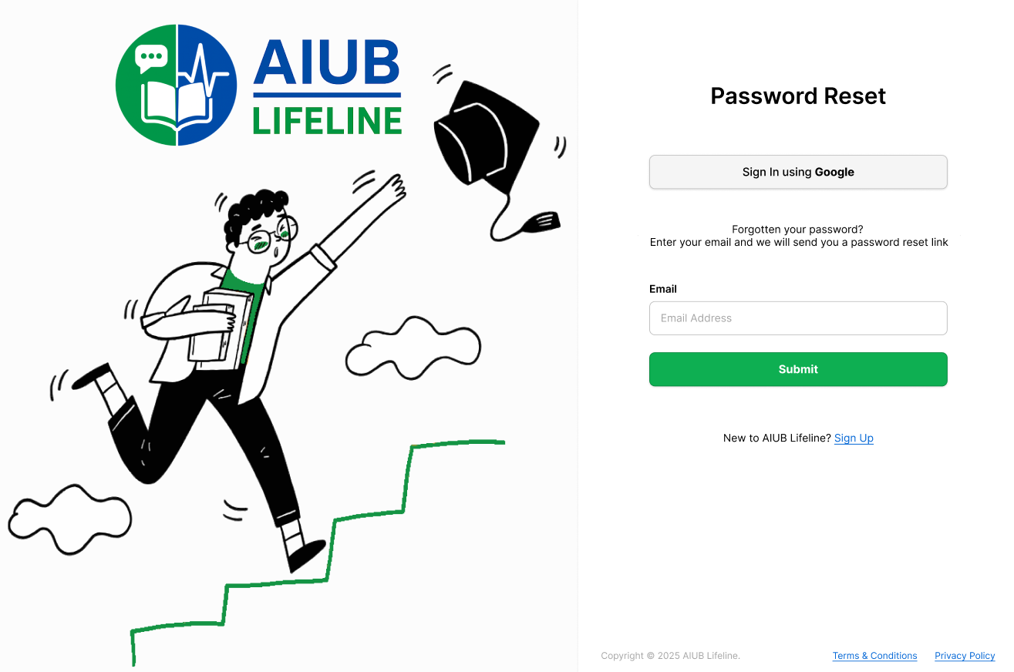

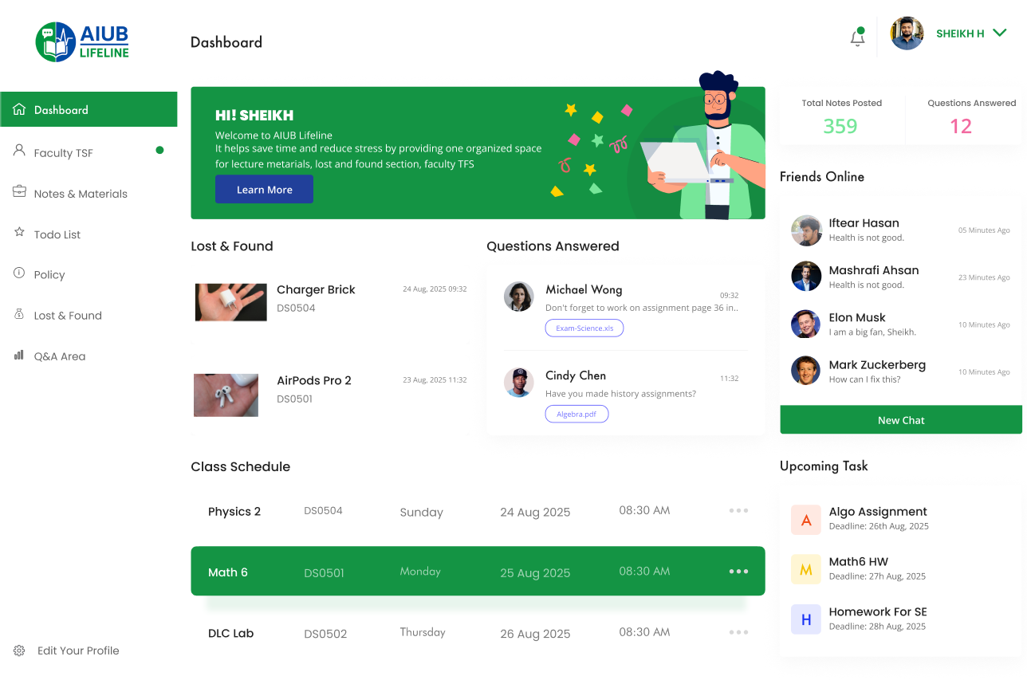**AIUB Lifeline- Student Dashboard**

**Chatbox**  
  
  
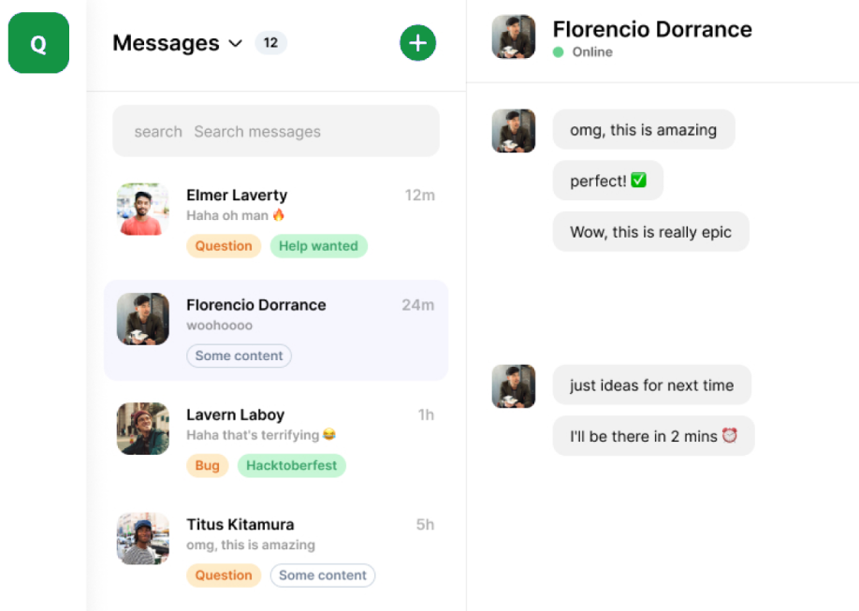

**AIUB Lifeline- Student Edit Profile**

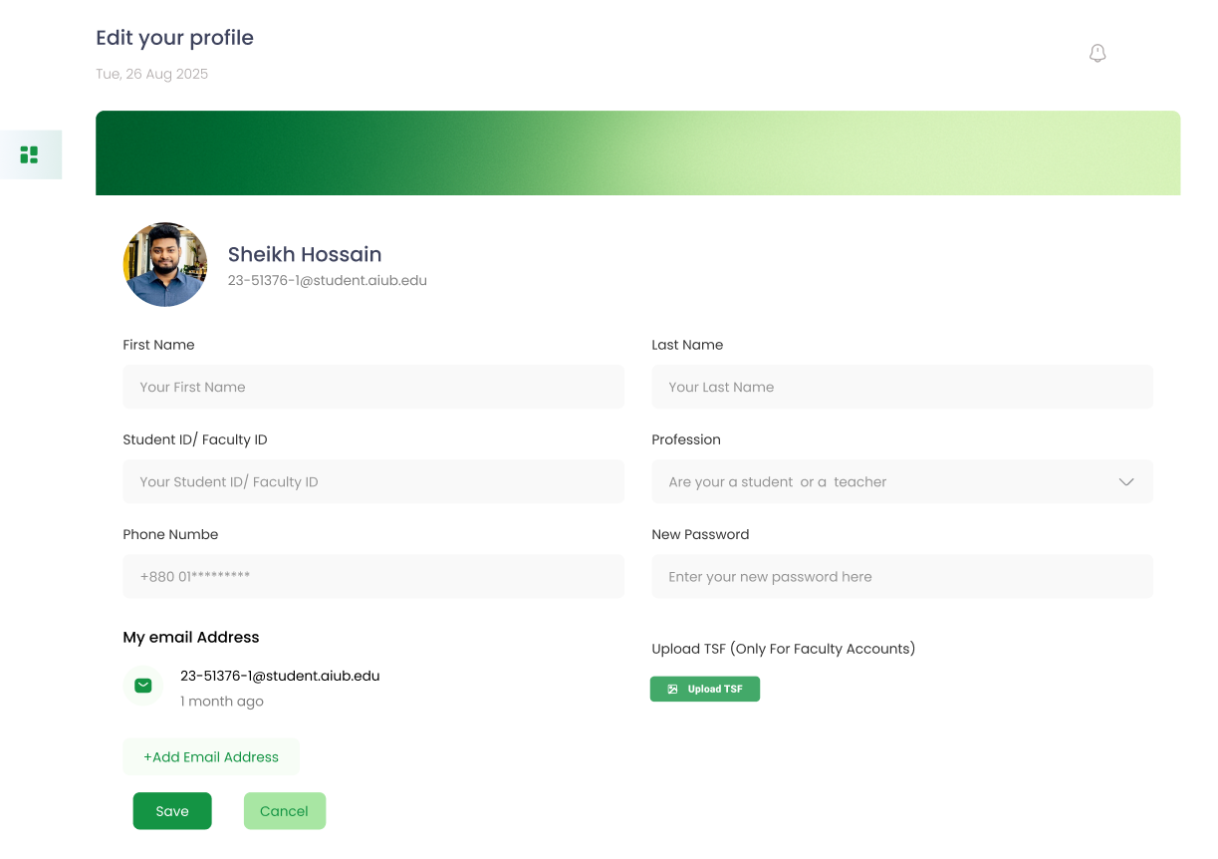

**AIUB Lifeline- Faculty Dashboard  
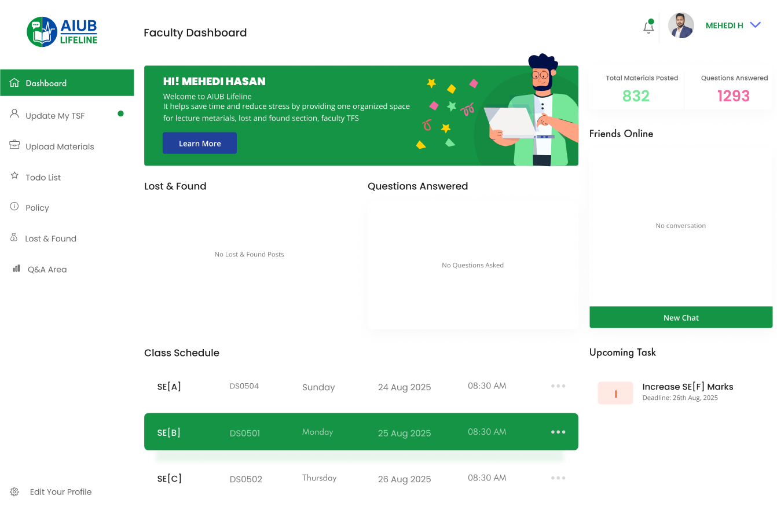  
  
  
  
  
  
  
  
  
  
  
  
  
  
  
  
  
  
  
  
  
AIUB Lifeline- Faculty Edit Profile  
  
  
  
  
  
  
  
  
  
  
  
  
  
  
  
AIUB Lifeline- Admin Dashboard**

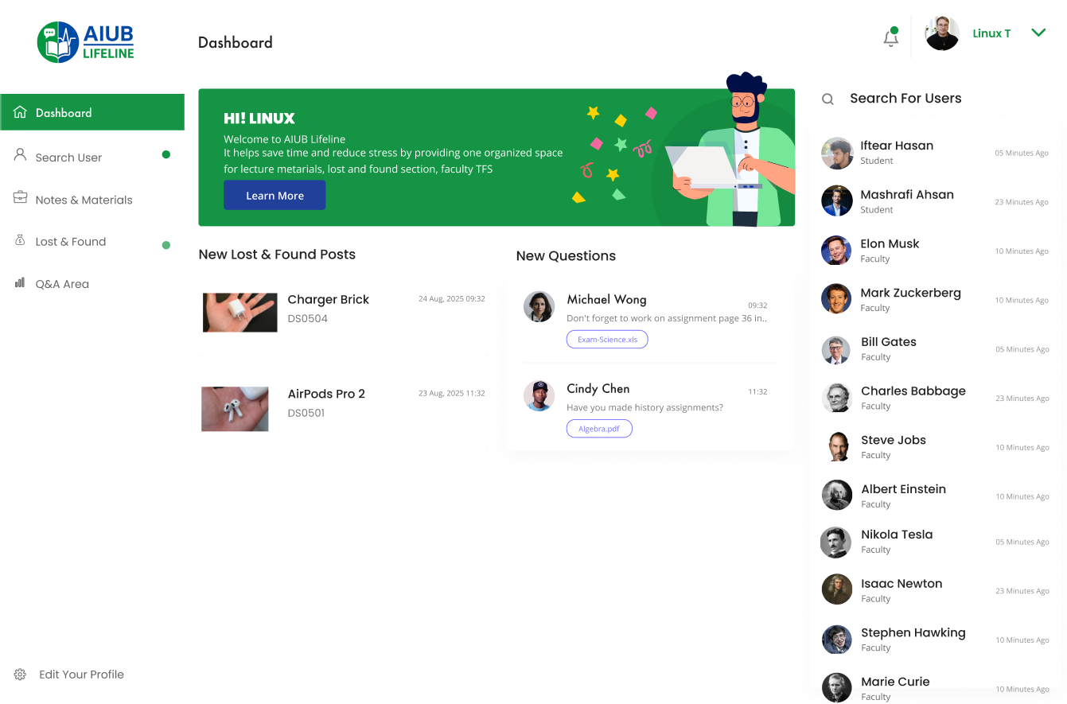

**AIUB Lifeline- Admin Edit Profile**



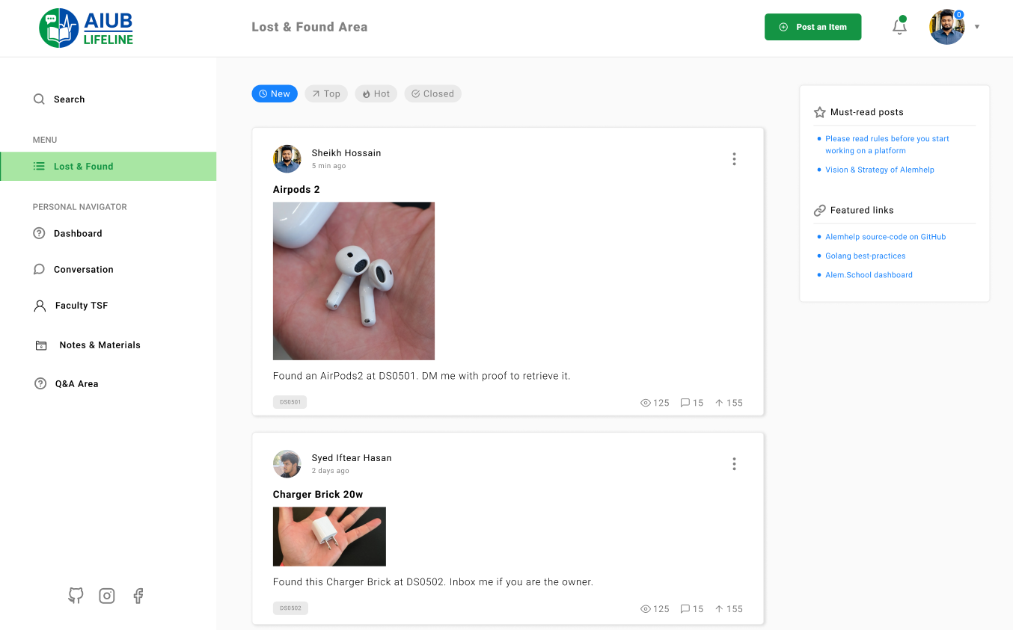**AIUB Lifeline- Lost & Found Area**

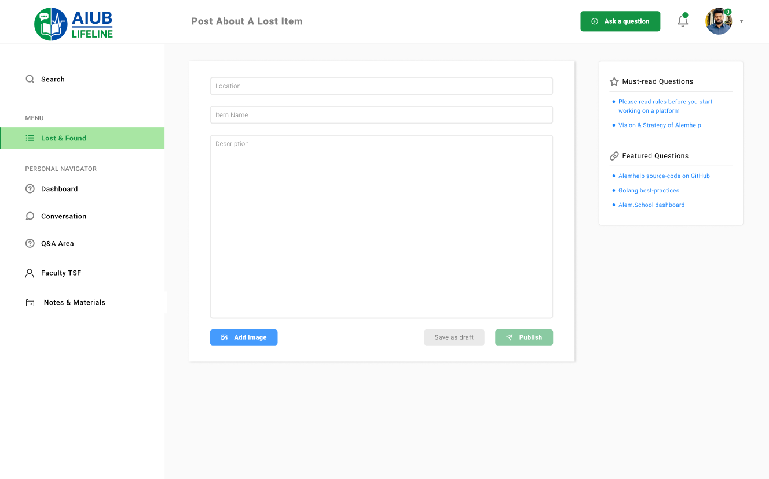 **AIUB Lifeline- Post about a lost item**

**AIUB Lifeline- Lecture Material & Notes Area**  
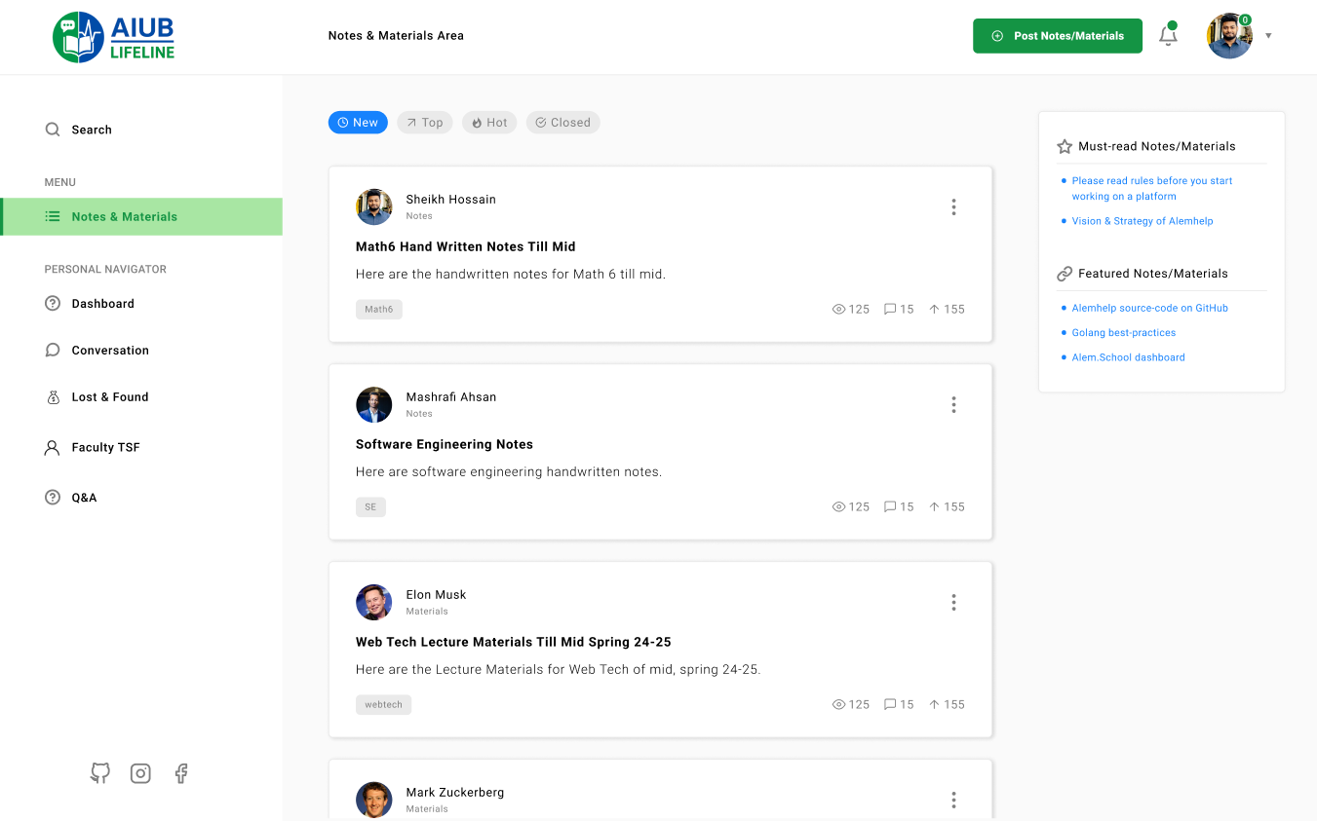  
**AIUB Lifeline- Post a Note/Material**

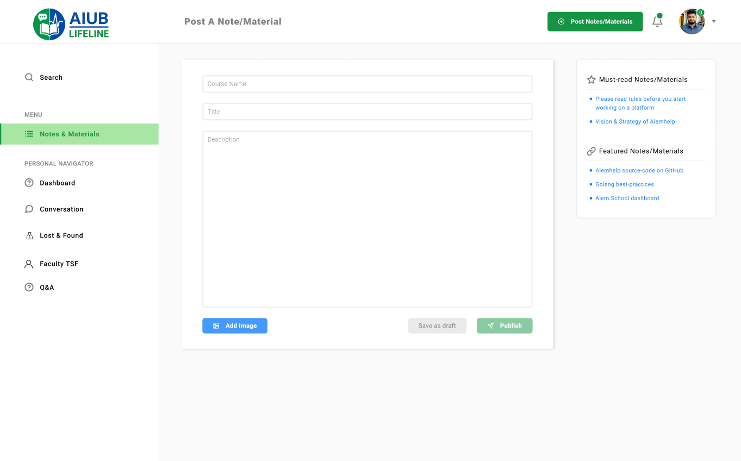

**AIUB Lifeline- Open Notes/Material**  
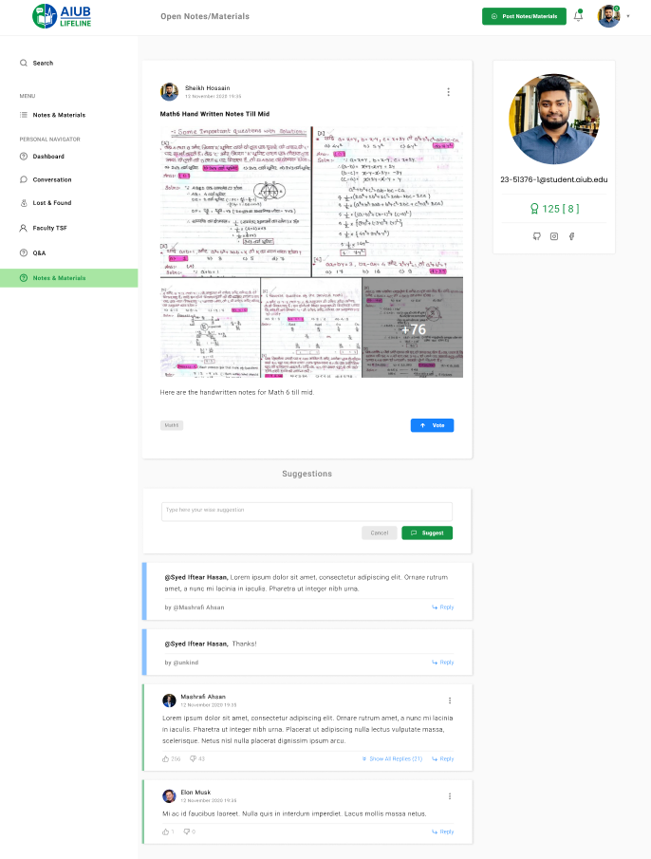

**AIUB Lifeline- Faculty TFS Search**  
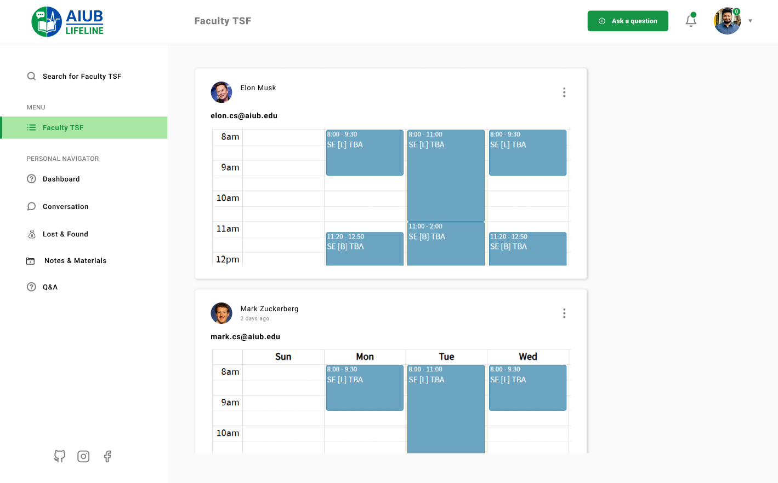

**AIUB Lifeline- Q&A Area**

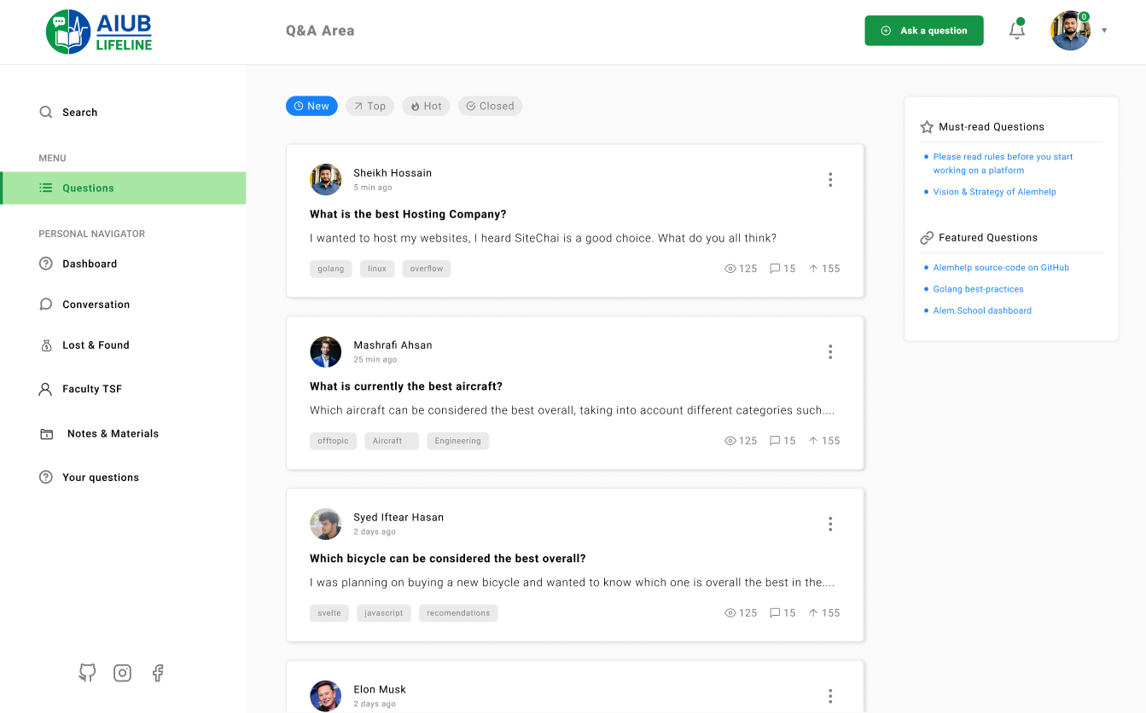

**AIUB Lifeline- Post a Question**  
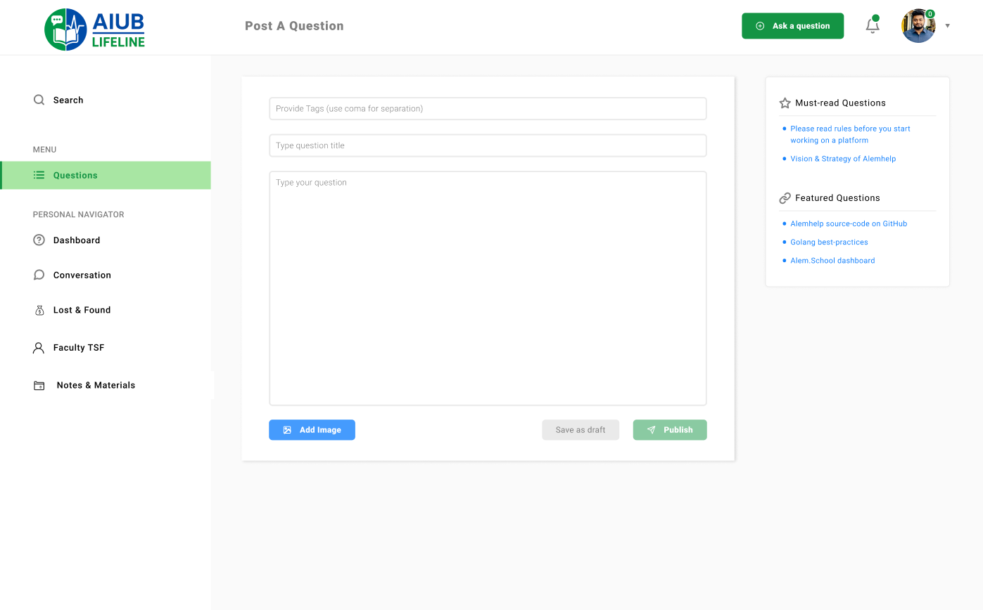

**AIUB Lifeline- View Question**

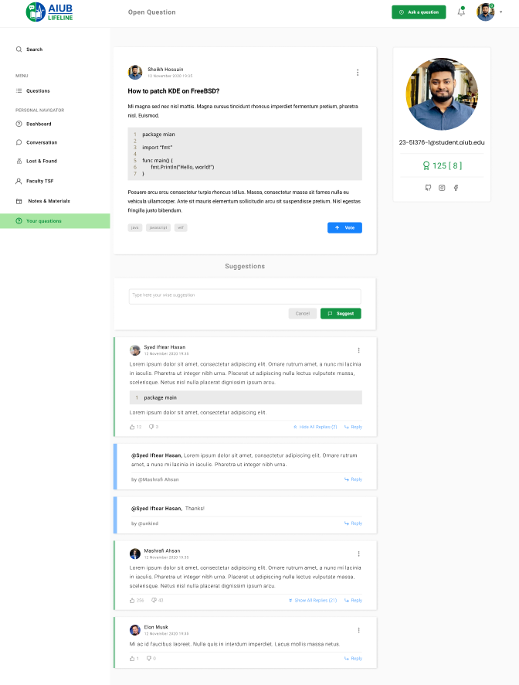

**AIUB Lifeline- Blogs**  
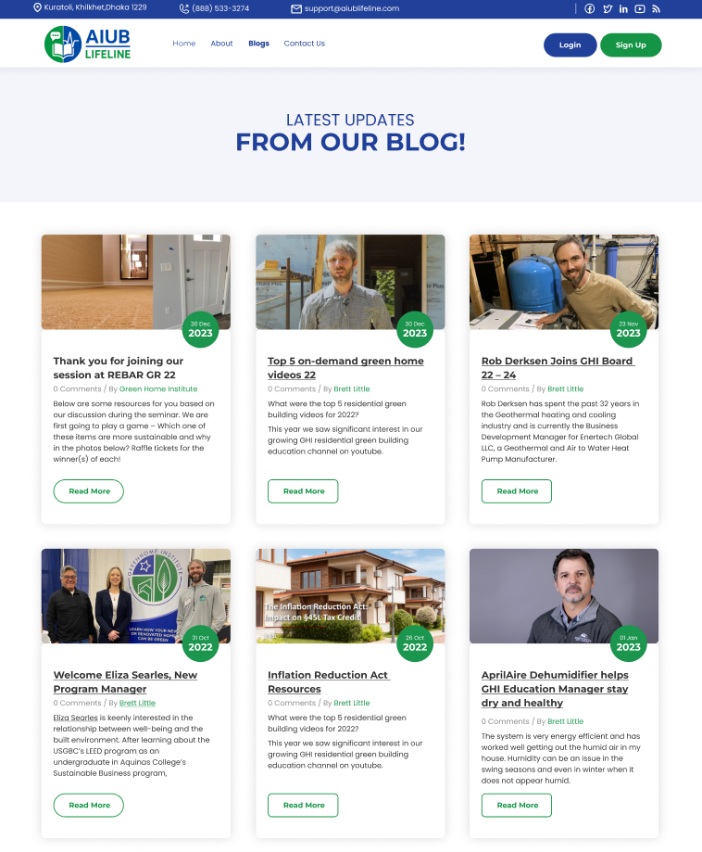  
  
  
  
  
**AIUB Lifeline- Blogs Detailed Page** 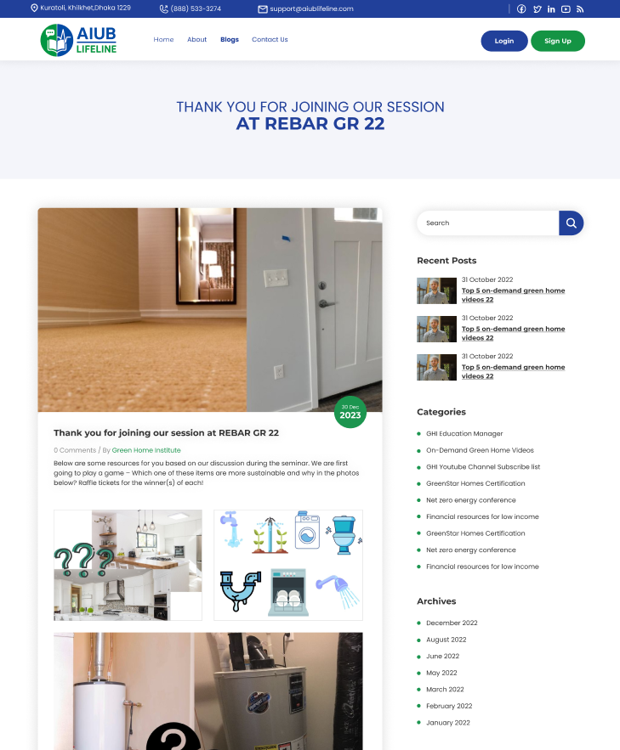   
 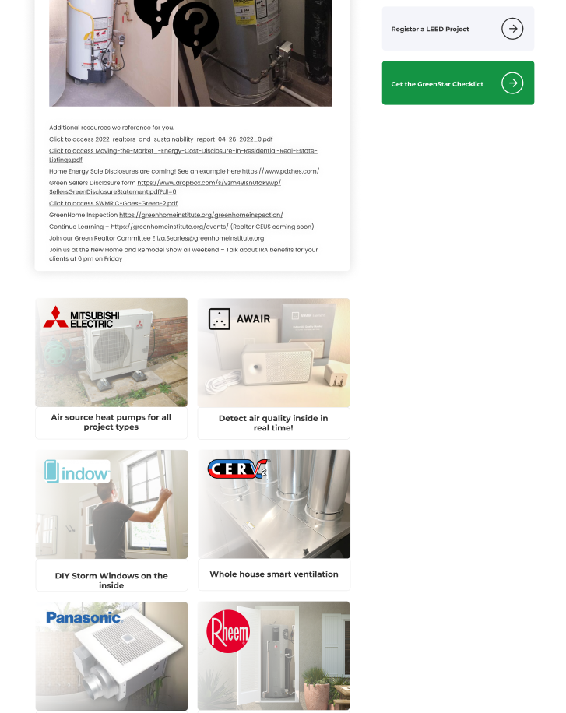

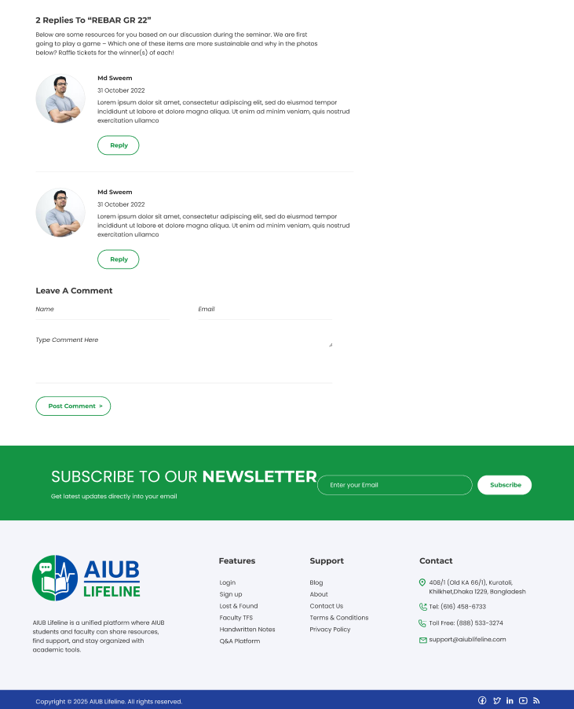

**AIUB Lifeline- About Page**  
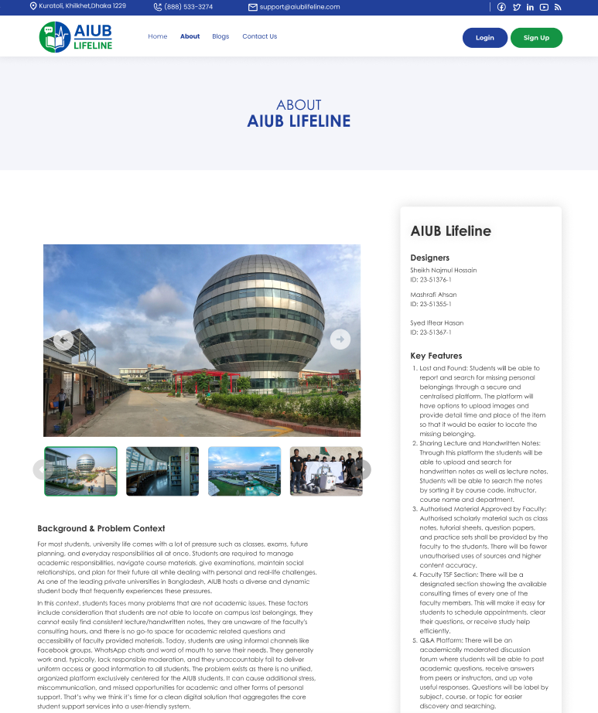  
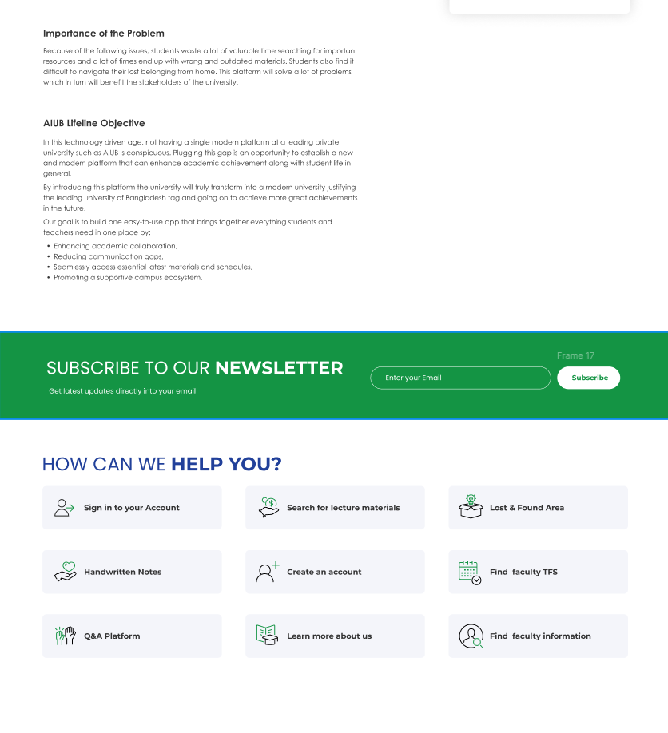  
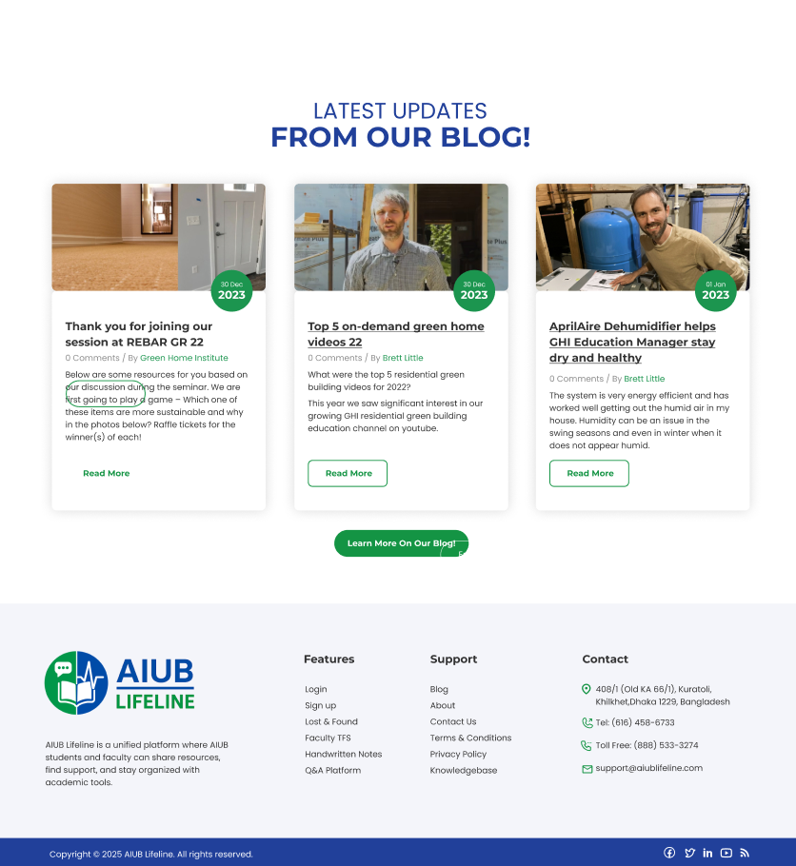

**AIUB Lifeline- Support Page**

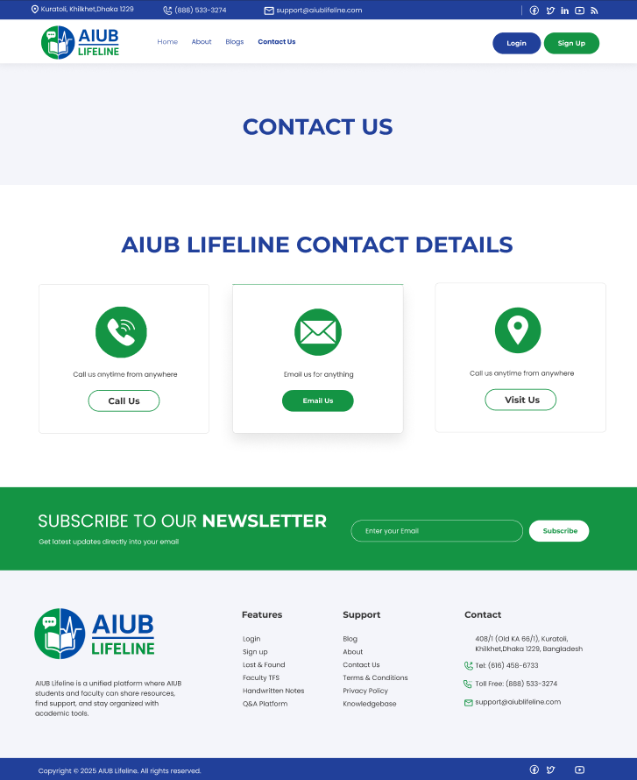

**AIUB Lifeline- Terms and Conditions**

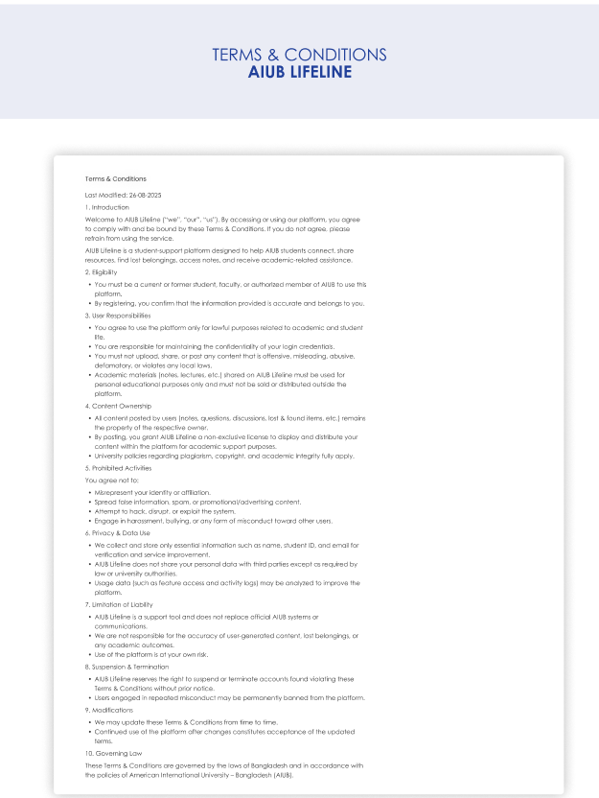

**AIUB Lifeline- Privacy Policy**  
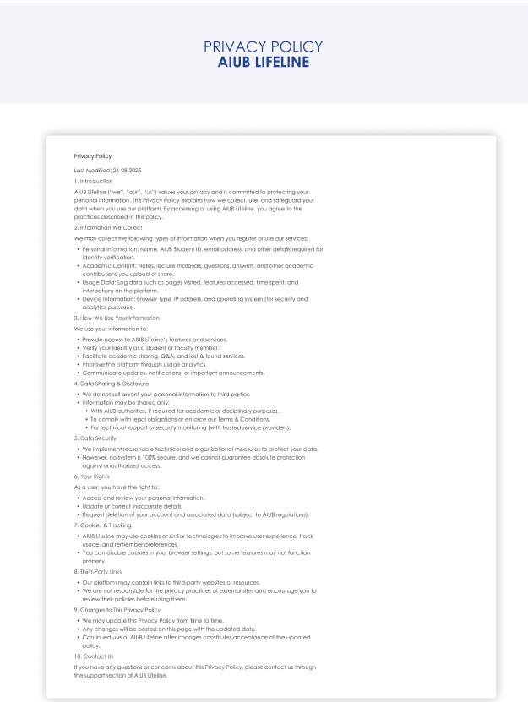

# GIT WORKFLOW

1. **Repo Creation**

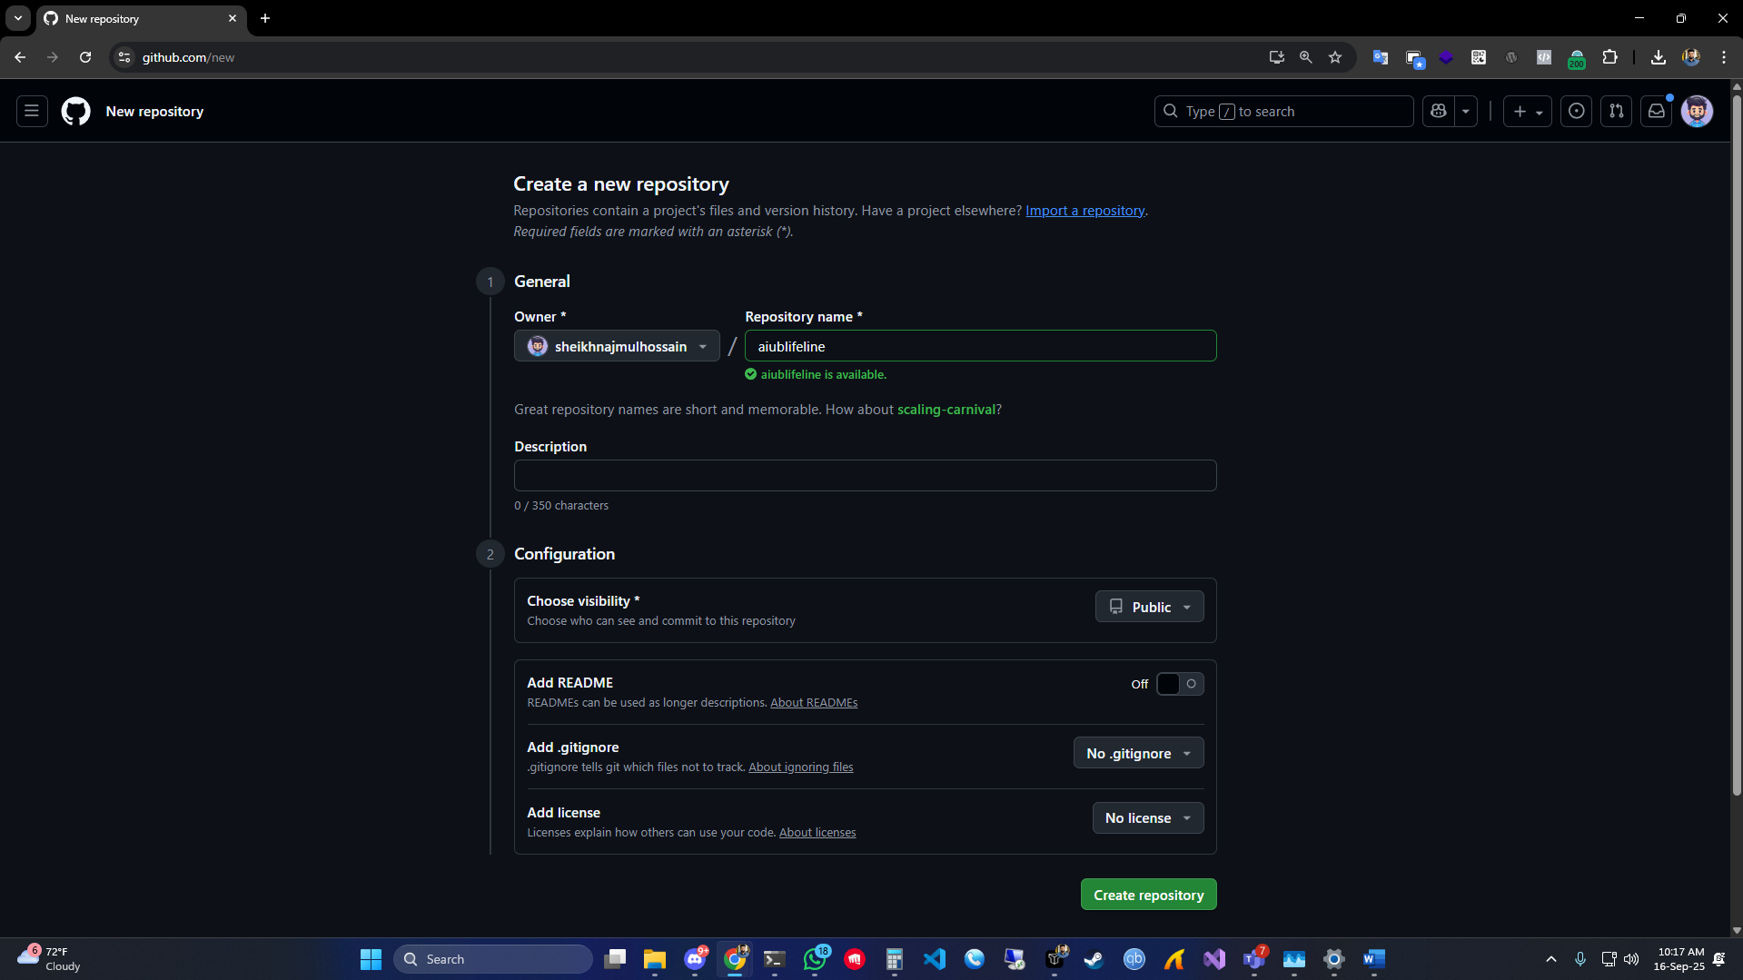

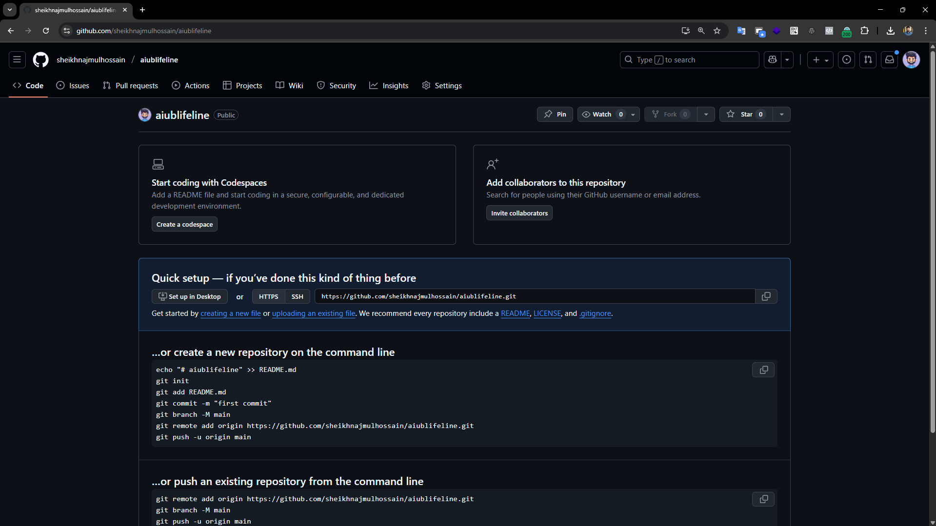

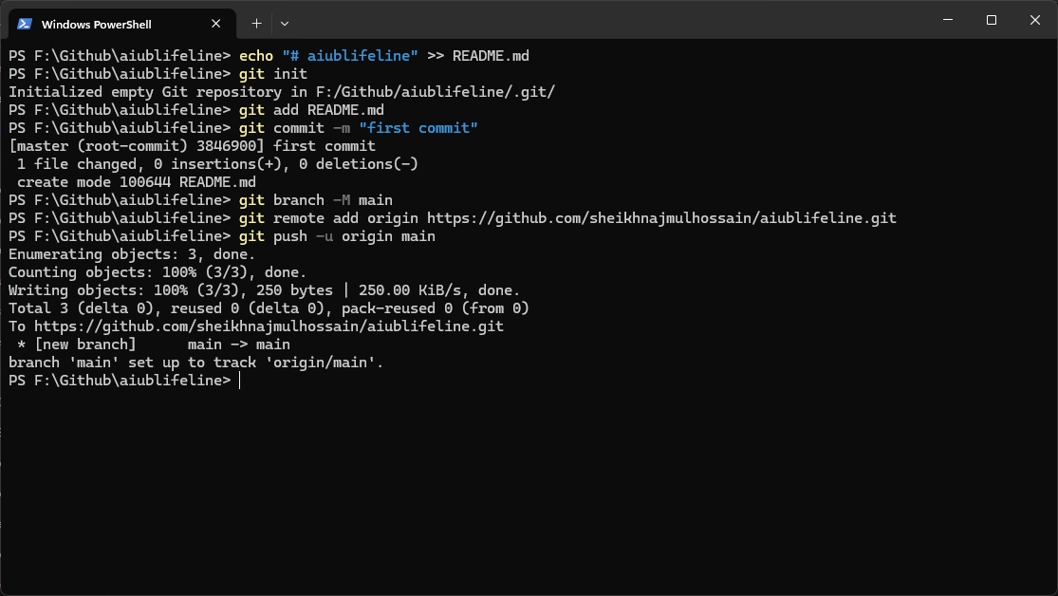

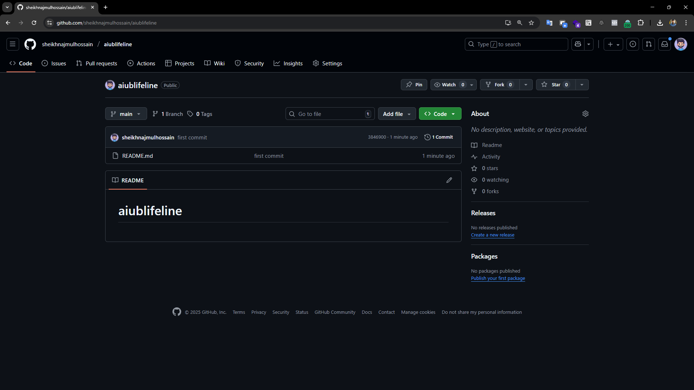

1. **Cloning the repo, creating own feature branches, committing each individual branch and pushing them.   
     
   Group Member: Mashrafi Ahsan  
   a. cloning repo  
      
   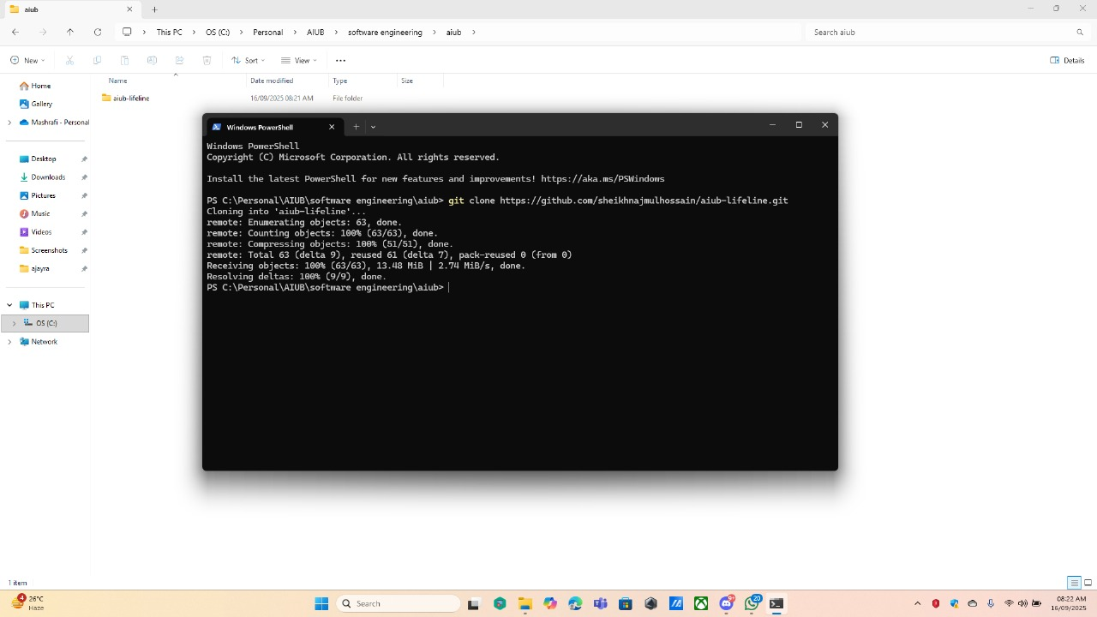**

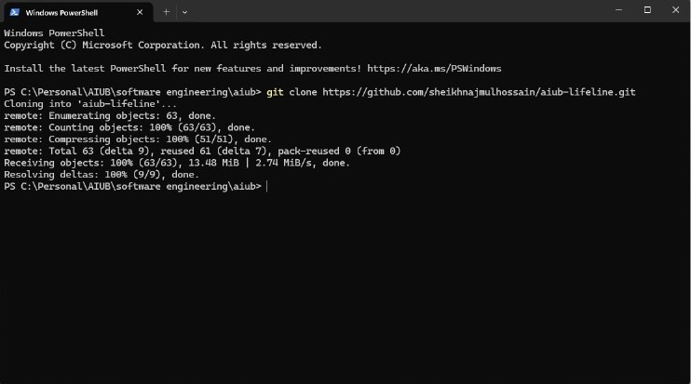

**b. creating branch named “mashrafibranch”**

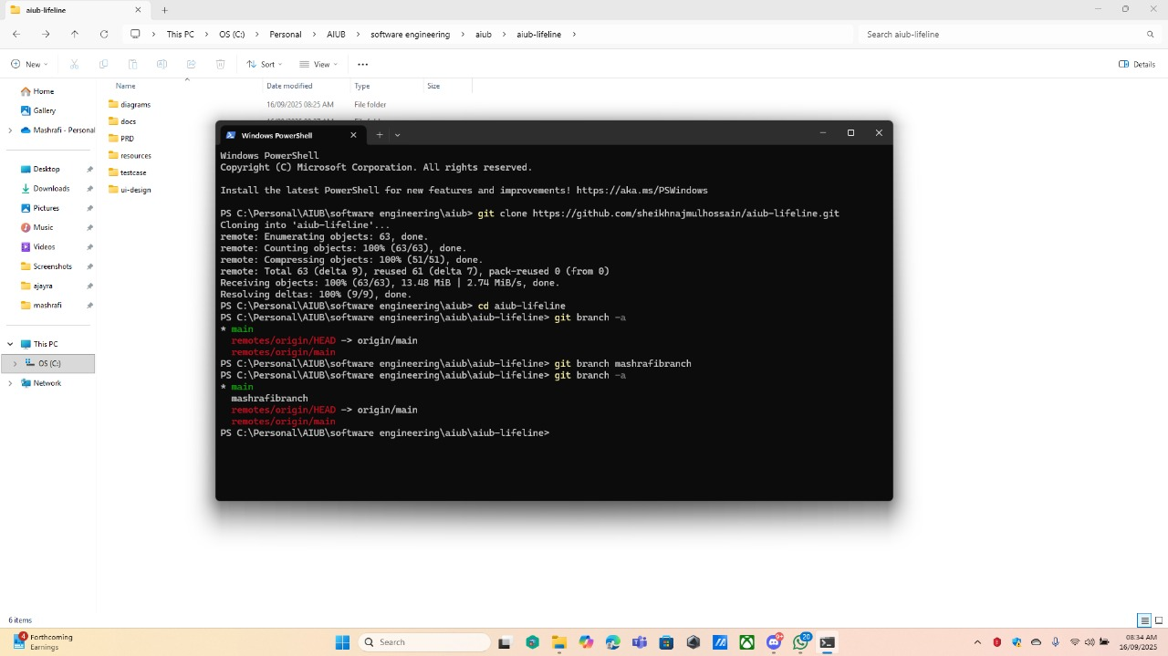

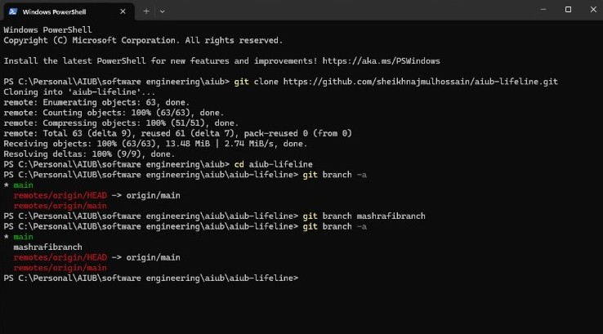

**c. Pushing first commit   
  
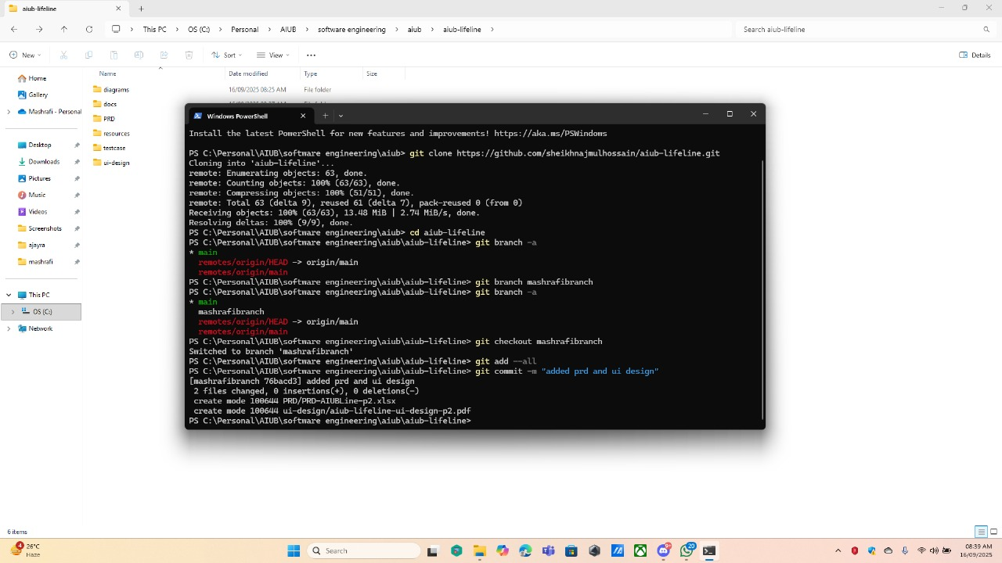**

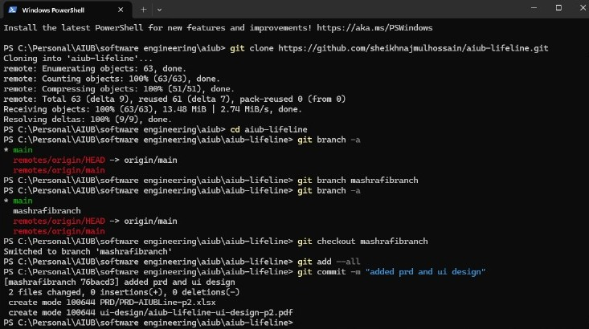

**d. Pushing second commit  
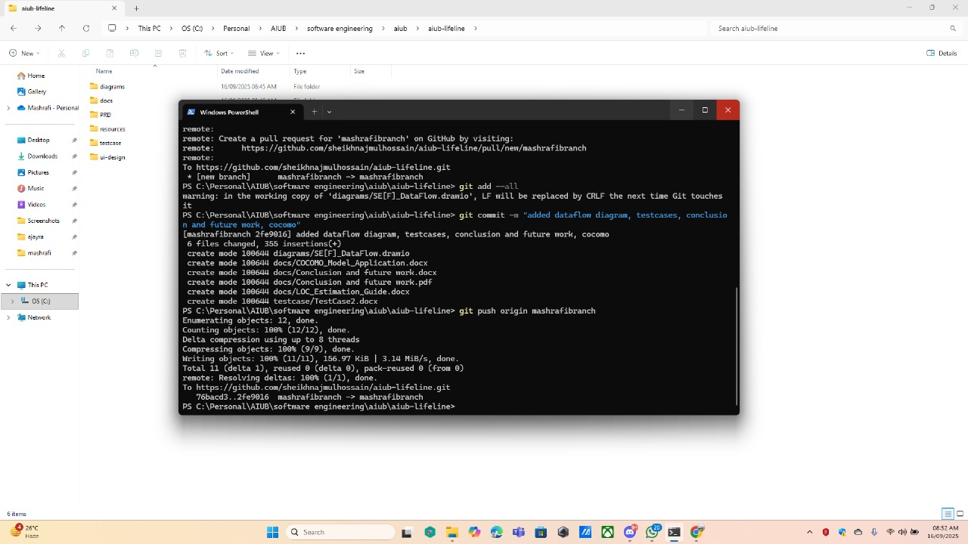**

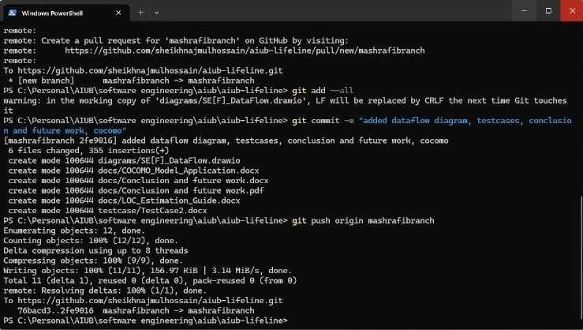

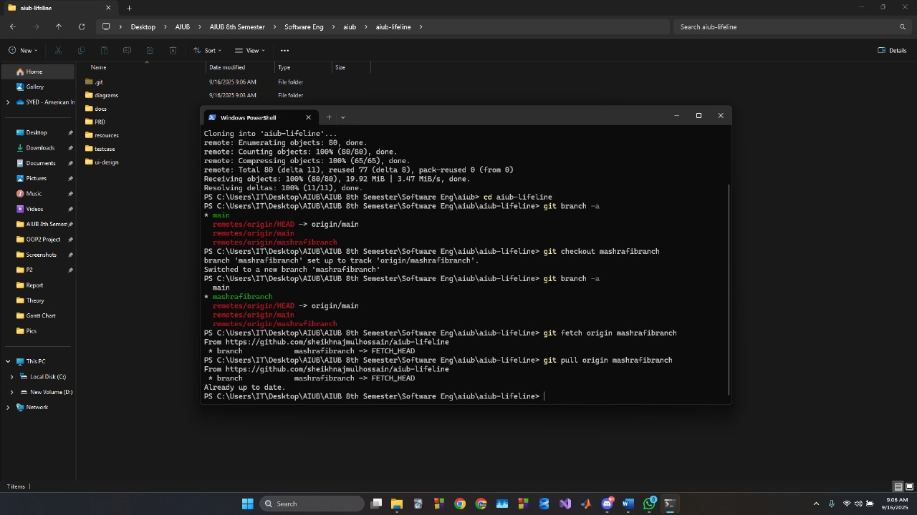 **Group Member: Syed Iftear Hasan  
  
a. Cloning repo and pulling code  
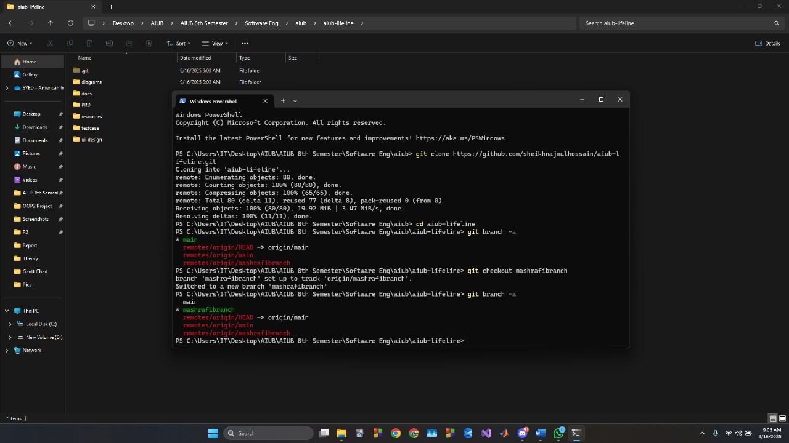**

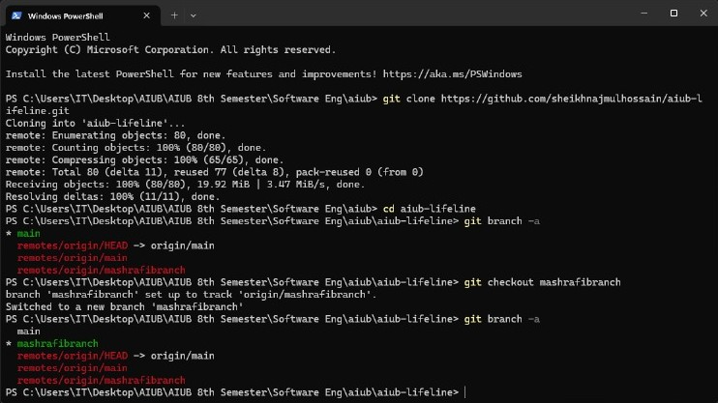

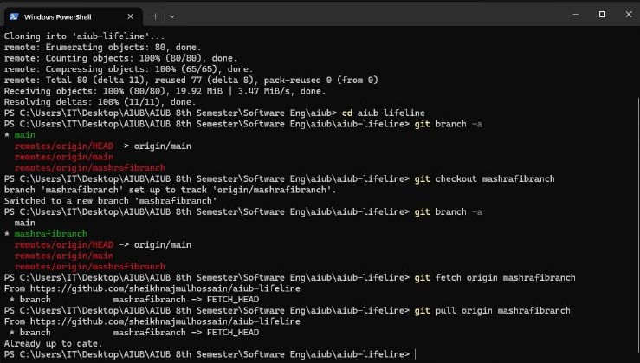

**b. Creating branch named “iftearbranch”**

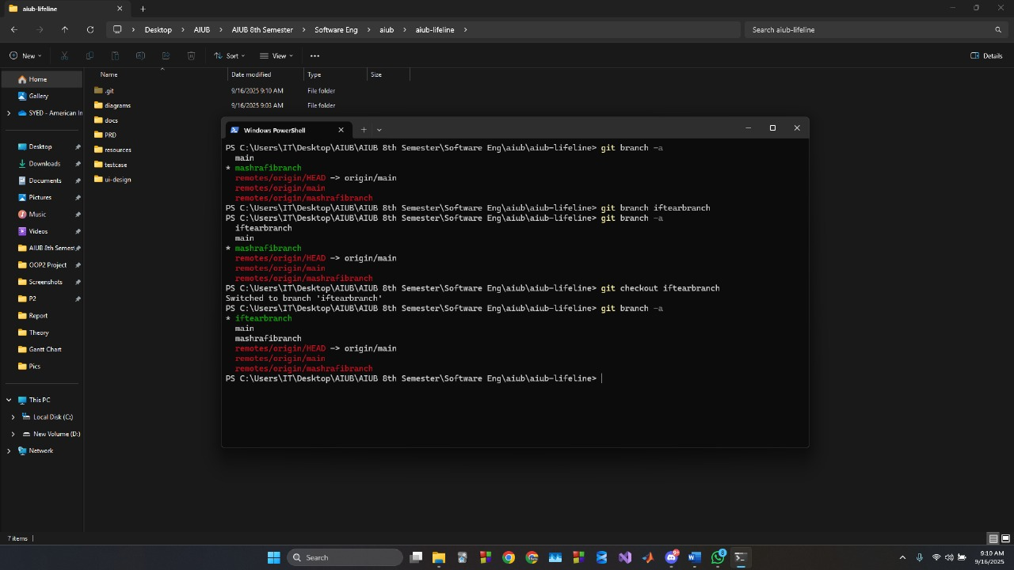

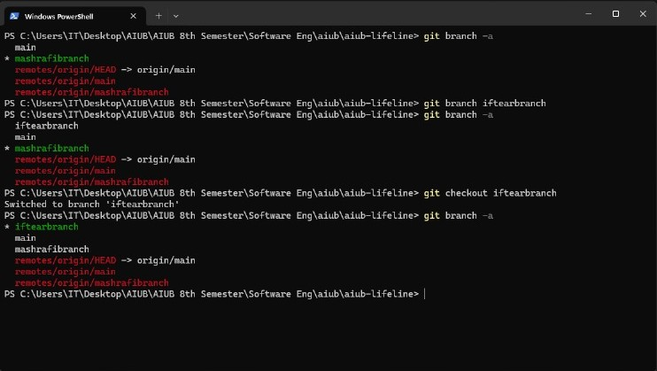

**c. First commit and push**

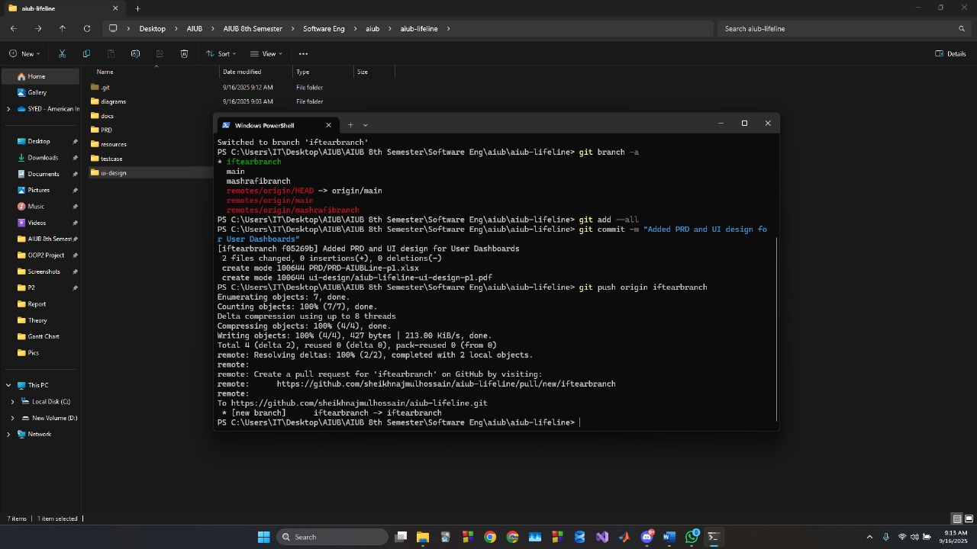

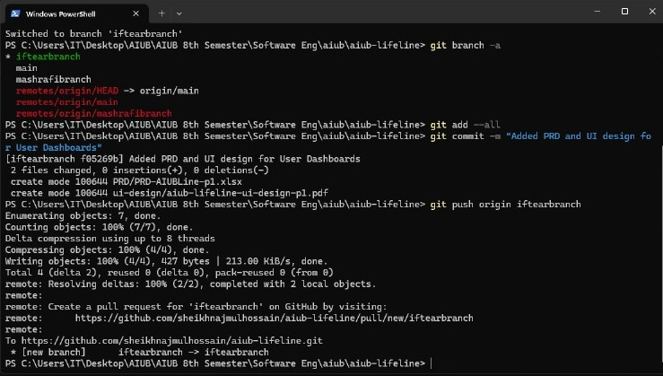

**d. Second commit and push**

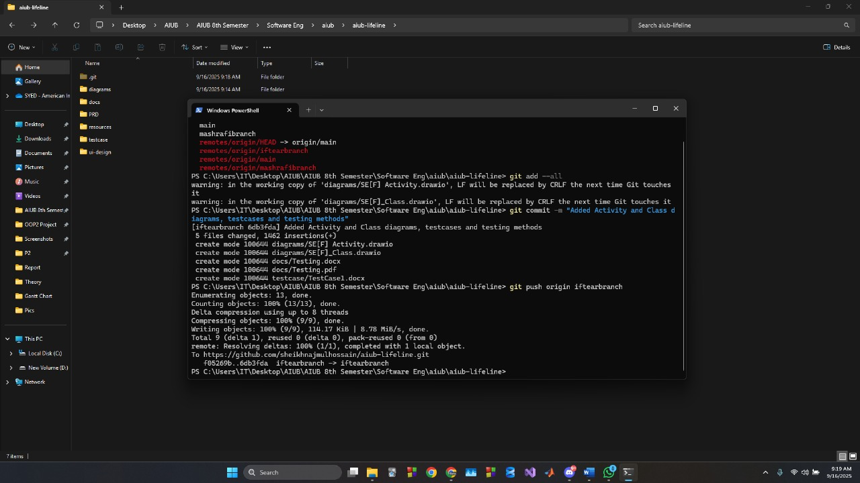

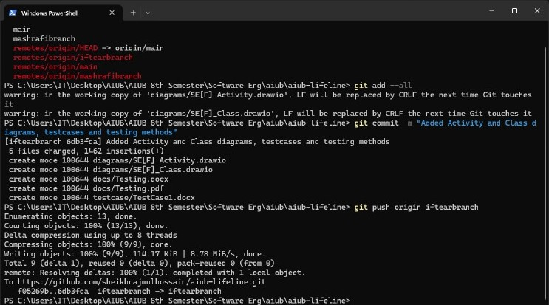

**Group Member: Sheikh Najmul Hossain  
a. Cloning repo and pulling the code**

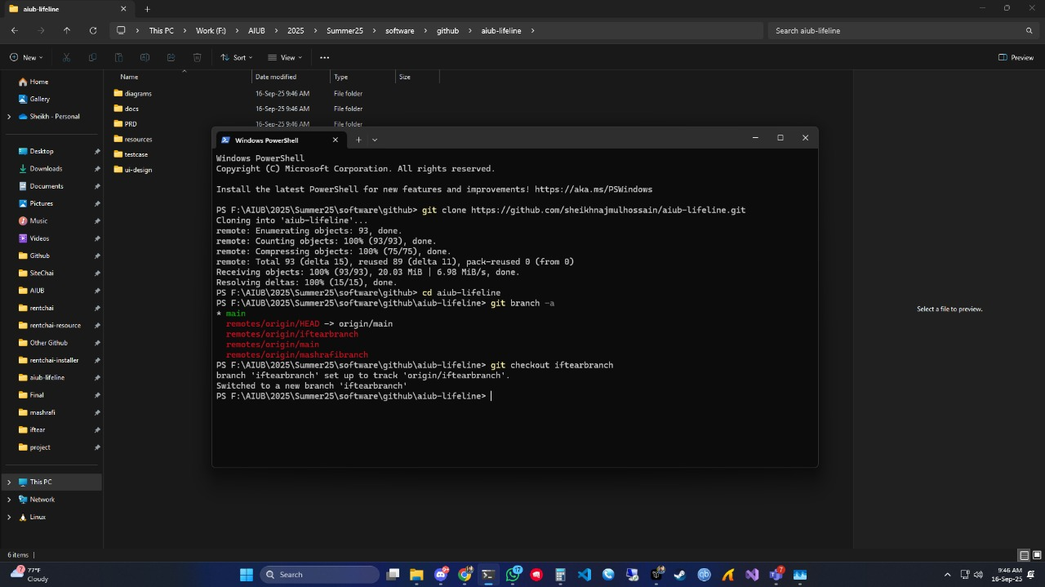

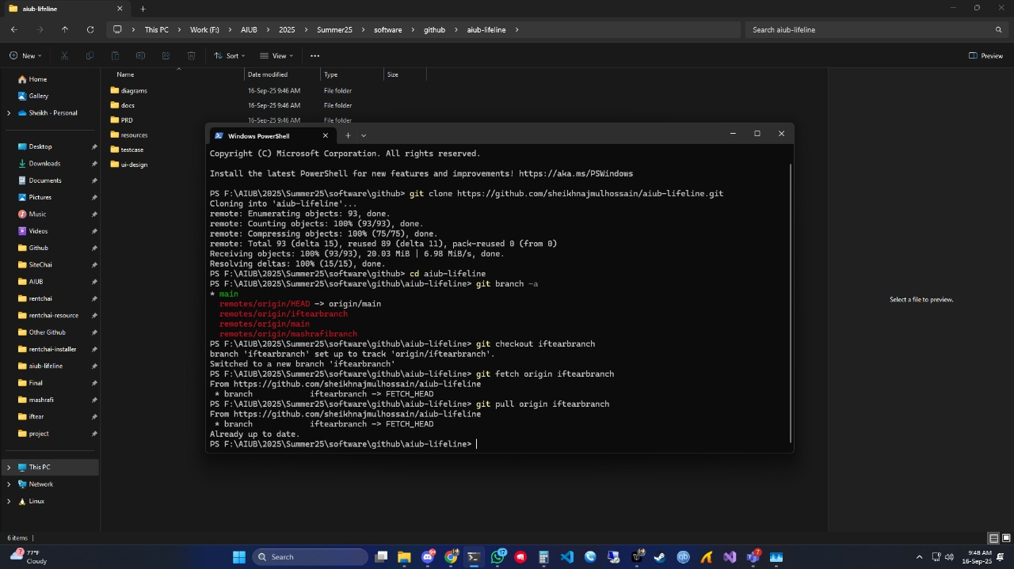

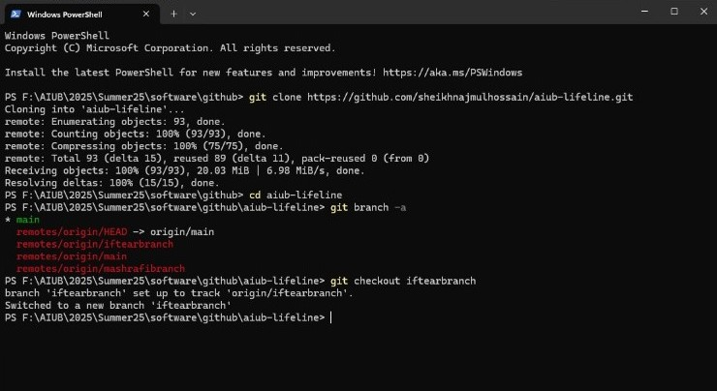

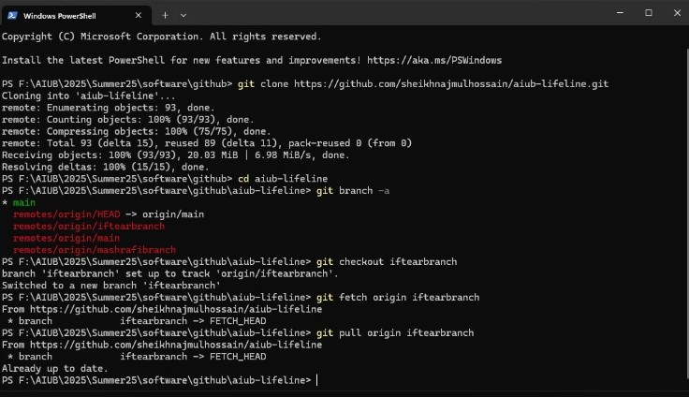

**b. Creating new branch named “najmulbranch”**

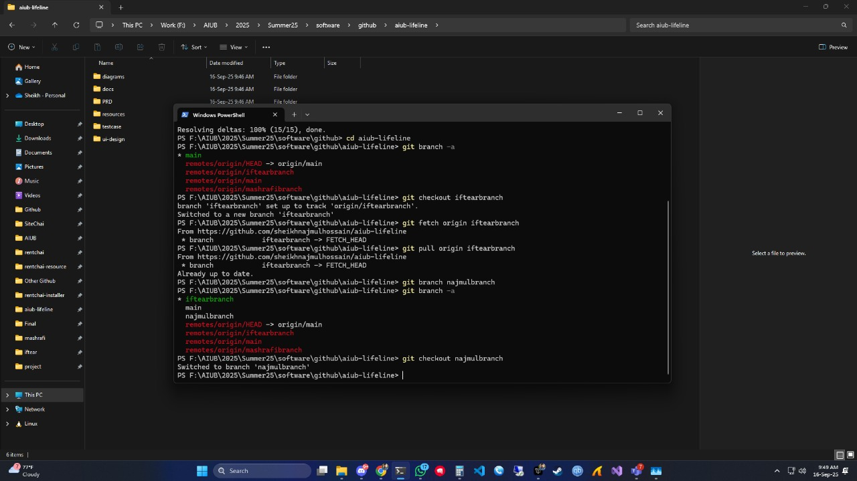

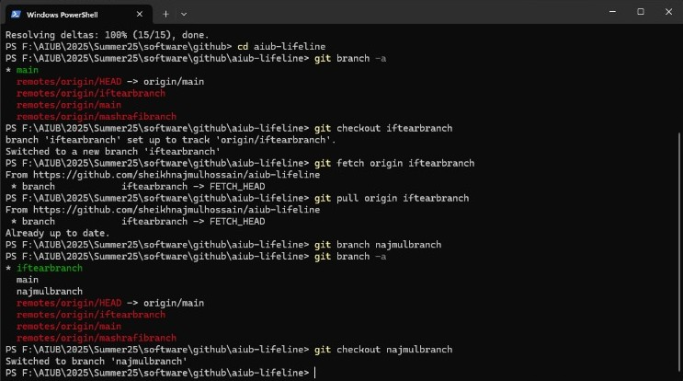

**c. First commit and push**

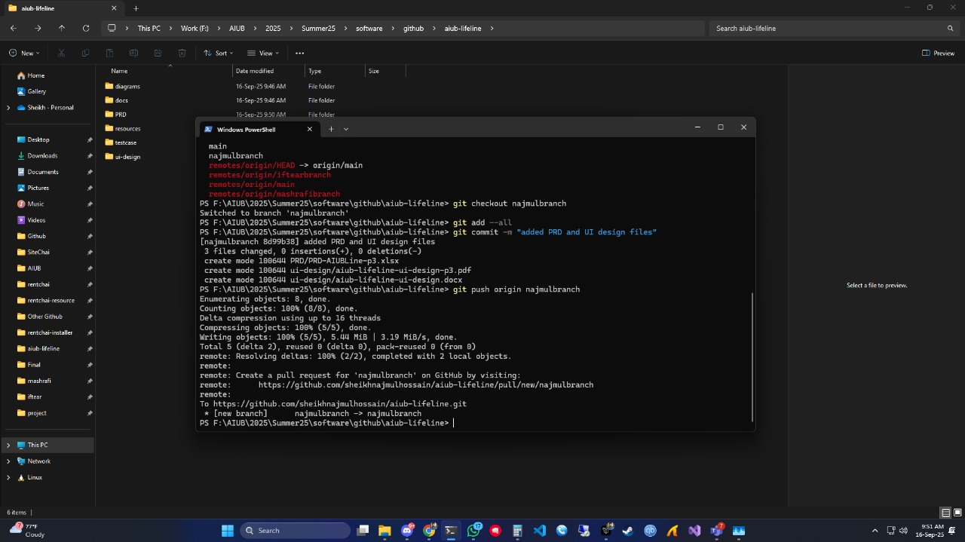

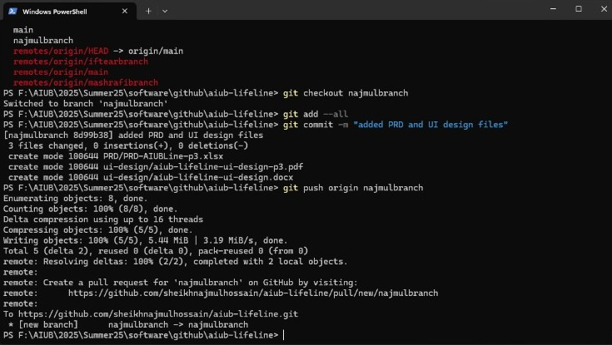

**d. Second commit and push**

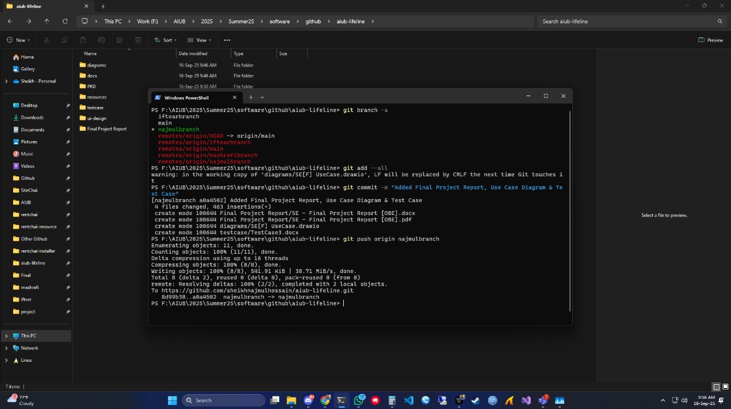

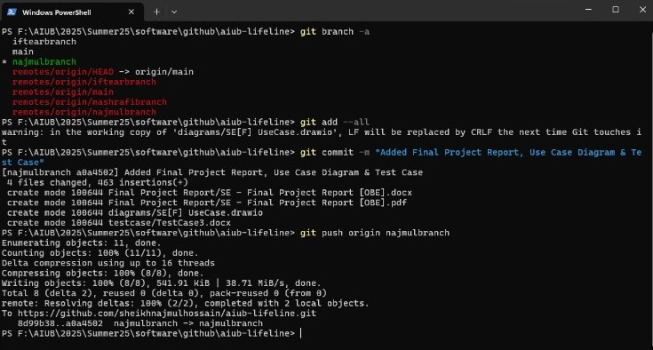

**e. Merging all the branches**

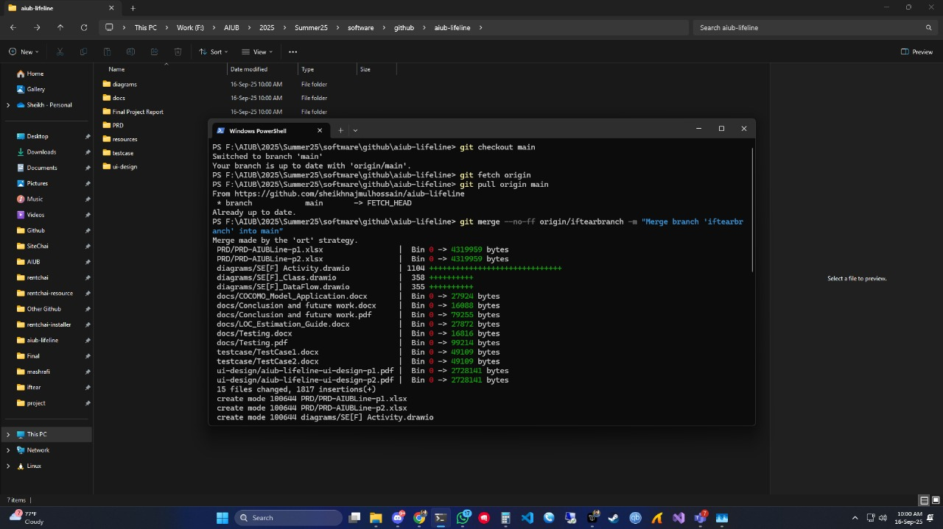

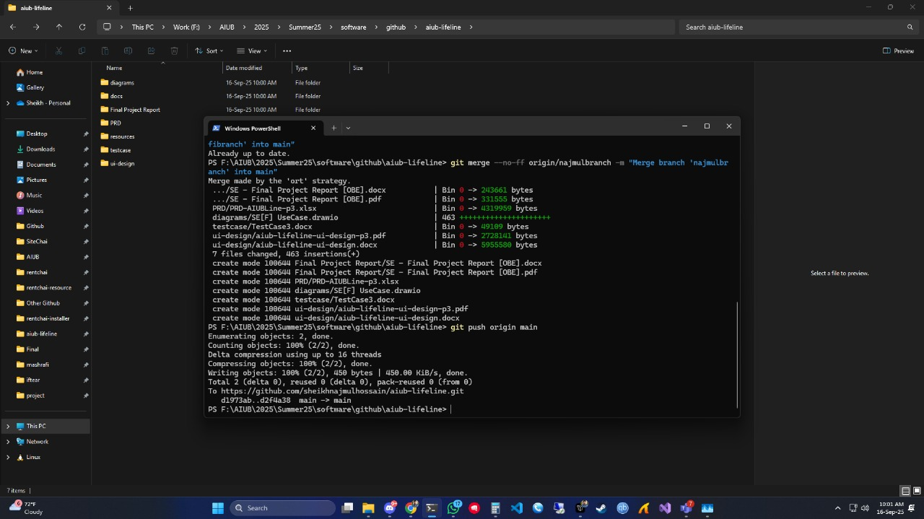

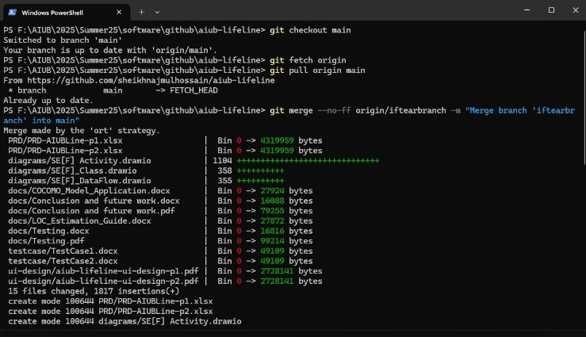

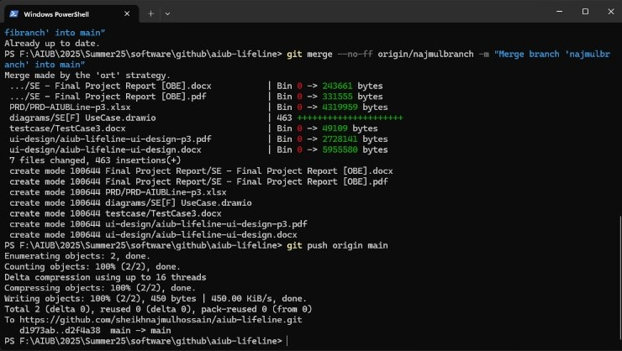

1. 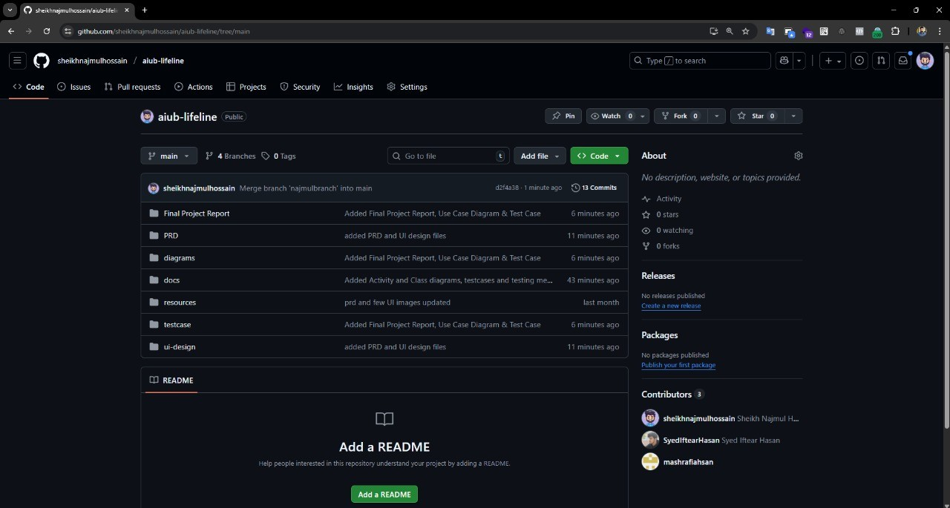**GitHub repo page and commit history**

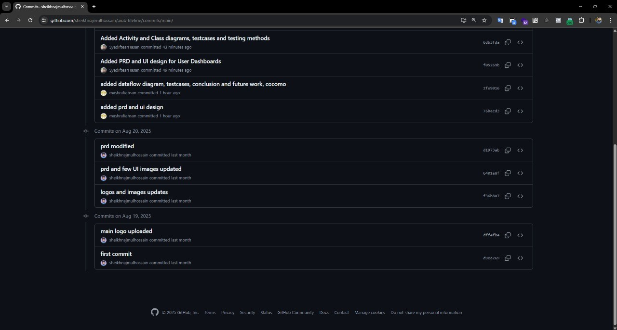

# TESTING

**A) How testing ensures quality and requirement conformance**

Testing is done to make sure the system works as planned and meets all the requirements. Each feature we write down in the requirements is linked with one or more test cases, so if the tests pass, we know the feature is working properly. If they fail, it shows there is a gap or a mistake.

By doing unit tests and integration tests early, problems are caught close to their source, which saves time and avoids rework later. Regression testing helps us check that new updates do not break features that were already working fine. Having clear acceptance tests and criteria also makes it easy to know when a feature is really “done” and ready, so there is no confusion.

On top of that, testing is not just about functionality. We also test non-functional areas like performance, security, usability, and compatibility. These ensure the system is fast, safe, easy to use, and works properly across different devices and browsers.

**B) Testing methods to be used later in the project**

Functional testing

* Unit Testing: Checking small parts of the code like methods and functions to make sure they behave correctly.
* Integration Testing: Making sure different modules (like login, profile, posting features) work well together.
* System/End-to-End Testing: Running through real scenarios a student or teacher would follow to confirm the whole system works smoothly.
* Regression Testing: Re-running older test cases to be sure that new updates didn’t break anything.
* User Acceptance Testing (UAT): Final checks by actual users to confirm the system meets their needs.

Non-functional testing

* Performance Testing: Checking how fast pages load and how the system handles multiple users.
* Security Testing: Making sure login, data handling, and file uploads are secure.
* Usability Testing: Seeing if users can easily finish tasks without confusion.
* Compatibility Testing: Ensuring the system works well across major browsers and devices.
* Accessibility Testing: Making sure the system is usable by everyone, including those with disabilities (e.g., keyboard navigation, proper contrast, alt text).

**C) Test Cases**

|  |  |  |  |  |  |
| --- | --- | --- | --- | --- | --- |
| **Project Name: AIUB Lifeline** | | | **Test Designed by: Sheikh Najmul Hossain** | | |
| **Test Case ID: TC_1** | | | Test Designed date: 26/8/2025 | | |
| **Test Priority (Low, Medium, High): Medium** | | | Test Executed by: Sheikh Najmul Hossain | | |
| **Module Name: Login Session** | | | Test Execution date: 30/08/2025 | | |
| **Test Title: Verify login with valid username and password** | | |  | | |
| **Description: Test the website login page** | | |  | | |
| **Precondition: The user has a valid username and password** | | | | | |
| **Dependencies:** | | | | | |
| **Test Steps** | **Test Data** | **Expected Results** | | **Actual Results** | **Status (Pass/Fail)** |
| 1. **Go to the site** 2. **Enter username** 3. **Enter password** 4. **Click on Sign In button** | Email: admin@gmail.com Password: Iopke_12# | The user should log in to the application | | As expected | Pass |

|  |  |  |  |  |  |
| --- | --- | --- | --- | --- | --- |
| **Project Name: AIUB Lifeline** | | | **Test Designed by: Sheikh Najmul Hossain** | | |
| **Test Case ID: TC_2** | | | Test Designed date: 27/8/2025 | | |
| **Test Priority (Low, Medium, High): High** | | | Test Executed by: Sheikh Najmul Hossain | | |
| **Module Name: Signup Session** | | | Test Execution date: 31/08/2025 | | |
| **Test Title: Check if users can signup successfully** | | |  | | |
| **Description: Test the website signup page** | | |  | | |
| **Precondition: The user needs to have a valid email and password needs to meet criteria** | | | | | |
| **Dependencies:** | | | | | |
| **Test Steps** | **Test Data** | **Expected Results** | | **Actual Results** | **Status (Pass/Fail)** |
| 1. **Go to the site** 2. **Enter First Name** 3. **Enter Last Name** 4. **Enter Account Type** 5. **Enter Email Address** 6. **Enter Password** 7. **Agree to Terms & Conditions** 8. **Click on Sign Up button** | First Name: Sheikh  Last Name: Hossain  Account Type: Student  Email: [najmul@gmail.com](mailto:najmul@gmail.com)  Password: Keqwp_3# | The user should signup successfully | | As expected | Pass |

|  |  |  |  |  |  |
| --- | --- | --- | --- | --- | --- |
| **Project Name: AIUB Lifeline** | | | **Test Designed by: Mashrafi Ahsan** | | |
| **Test Case ID: TC_3** | | | Test Designed date: 28/8/2025 | | |
| **Test Priority (Low, Medium, High): Low** | | | Test Executed by: Mashrafi Ahsan | | |
| **Module Name: Subscribe to Newsletter Session** | | | Test Execution date: 01/09/2025 | | |
| **Test Title: Check if user can subscribe to newsletter** | | |  | | |
| **Description: Test the website signup page** | | |  | | |
| **Precondition: The user needs to have a valid email** | | | | | |
| **Dependencies:** | | | | | |
| **Test Steps** | **Test Data** | **Expected Results** | | **Actual Results** | **Status (Pass/Fail)** |
| 1. **Go to the site** 2. **Enter Email Address** 3. **Click on Subscribe Button** | Email: [najmul@gmail.com](mailto:najmul@gmail.com) | The user should successfully be subscribed to the newsletter | | As expected | Pass |

|  |  |  |  |  |  |
| --- | --- | --- | --- | --- | --- |
| **Project Name: AIUB Lifeline** | | | **Test Designed by: Mashrafi Ahsan** | | |
| **Test Case ID: TC_4** | | | Test Designed date: 29/8/2025 | | |
| **Test Priority (Low, Medium, High): Medium** | | | Test Executed by: Mashrafi Ahsan | | |
| **Module Name: Password Reset Session** | | | Test Execution date: 02/09/2025 | | |
| **Test Title: Check if users can reset their password successfully** | | |  | | |
| **Description: Test the Password Reset page** | | |  | | |
| **Precondition: The email has to be already registered** | | | | | |
| **Dependencies:** | | | | | |
| **Test Steps** | **Test Data** | **Expected Results** | | **Actual Results** | **Status (Pass/Fail)** |
| 1. **Go to the site** 2. **Enter Email** 3. **Click Submit** | Email: [najmul@gmail.com](mailto:najmul@gmail.com) | The user should receive a password reset email | | Resetting the password was unsuccessful, SMTP error. | Fail |

|  |  |  |  |  |  |
| --- | --- | --- | --- | --- | --- |
| **Project Name: AIUB Lifeline** | | | **Test Designed by: Mashrafi Ahsan** | | |
| **Test Case ID: TC_5** | | | Test Designed date: 30/8/2025 | | |
| **Test Priority (Low, Medium, High): Medium** | | | Test Executed by: Mashrafi Ahsan | | |
| **Module Name: Edit Profile Session** | | | Test Execution date: 03/09/2025 | | |
| **Test Title: Check if user can edit their profile** | | |  | | |
| **Description: Test the website edit profile page** | | |  | | |
| **Precondition: The user needs to have an active account logged in** | | | | | |
| **Dependencies:** | | | | | |
| **Test Steps** | **Test Data** | **Expected Results** | | **Actual Results** | **Status (Pass/Fail)** |
| 1. **Go to the site** 2. **Login** 3. **Click on edit profile** 4. **Make the change, change phone number** 5. **Click on save** | Email: [najmul@gmail.com](mailto:najmul@gmail.com)  Password: Keqwp_3#  New Phone Number: 01879746427 | Profile information changed successfully | | As expected | Pass |

|  |  |  |  |  |  |
| --- | --- | --- | --- | --- | --- |
| **Project Name: AIUB Lifeline** | | | **Test Designed by: Syed Iftear Hasan** | | |
| **Test Case ID: TC_6** | | | Test Designed date: 31/8/2025 | | |
| **Test Priority (Low, Medium, High): High** | | | Test Executed by: Syed Iftear Hasan | | |
| **Module Name: Lost & Found Item Post Session** | | | Test Execution date: 04/09/2025 | | |
| **Test Title: Check if users can post lost & found items** | | |  | | |
| **Description: Test the website lost & found page** | | |  | | |
| **Precondition: The user needs to have an active account logged in & image needs to be png or jpg under 1MB** | | | | | |
| **Dependencies:** | | | | | |
| **Test Steps** | **Test Data** | **Expected Results** | | **Actual Results** | **Status (Pass/Fail)** |
| 1. **Go to the site** 2. **Login** 3. **Go to Lost & Found area** 4. **Click on Post an item** 5. **Enter location** 6. **Enter item name** 7. **Enter description** 8. **Add image** 9. **Click on Publish button** | Email: [najmul@gmail.com](mailto:najmul@gmail.com)  Password: Keqwp_3#  Location: DS0802  Item Name: Airpod Pro 2  Desctiption: Found Airpod Pro 2  Image of the item | The user should be able to post lost items successfully. | | As expected | Pass |

|  |  |  |  |  |  |
| --- | --- | --- | --- | --- | --- |
| **Project Name: AIUB Lifeline** | | | **Test Designed by: Sheikh Najmul Hossain** | | |
| **Test Case ID: TC_7** | | | Test Designed date: 01/9/2025 | | |
| **Test Priority (Low, Medium, High): Medium** | | | Test Executed by: Sheikh Najmul Hossain | | |
| **Module Name: Notes Post Session** | | | Test Execution date: 05/09/2025 | | |
| **Test Title: Check if users can post Notes items** | | |  | | |
| **Description: Test the website Notes page** | | |  | | |
| **Precondition: The user needs to have an active account logged in & image needs to be png or jpg under 1MB** | | | | | |
| **Dependencies:** | | | | | |
| **Test Steps** | **Test Data** | **Expected Results** | | **Actual Results** | **Status (Pass/Fail)** |
| 1. **Go to the site** 2. **Login** 3. **Go to Notes Area** 4. **Click on Post Notes** 5. **Enter Course Name** 6. **Enter title** 7. **Enter description** 8. **Add image** 9. **Click on Publish button** | Email: [najmul@gmail.com](mailto:najmul@gmail.com)  Password: Keqwp_3#  Course Name: Math6  Title: Math 6 Mid Notes Fall 24-25  Desctiption: Here are math 6 notes  Note pictures. | The user should be able to post notes successfully. | | As expected | Pass |

|  |  |  |  |  |  |
| --- | --- | --- | --- | --- | --- |
| **Project Name: AIUB Lifeline** | | | **Test Designed by: Syed Iftear Hasan** | | |
| **Test Case ID: TC_8** | | | Test Designed date: 03/9/2025 | | |
| **Test Priority (Low, Medium, High): Medium** | | | Test Executed by: Syed Iftear Hasan | | |
| **Module Name: Q&A Session** | | | Test Execution date: 06/09/2025 | | |
| **Test Title: Check if users can post questions successfully** | | |  | | |
| **Description: Test the website Q&A page** | | |  | | |
| **Precondition: The user needs to have an active account logged in** | | | | | |
| **Dependencies:** | | | | | |
| **Test Steps** | **Test Data** | **Expected Results** | | **Actual Results** | **Status (Pass/Fail)** |
| 1. **Go to the site** 2. **Log in** 3. **Go to Q&A area** 4. **Click on Ask a question** 5. **Enter tags** 6. **Enter question title** 7. **Enter the question** 8. **Add image** 9. **Click on publish button** | Email: [najmul@gmail.com](mailto:najmul@gmail.com)  Password: Keqwp_3#  Tags: ide  Question title: IDE for Python.  Question: What is the best IDE for Python | The user should successfully post questions. | | As expected | Pass |

|  |  |  |  |  |  |
| --- | --- | --- | --- | --- | --- |
| **Project Name: AIUB Lifeline** | | | **Test Designed by: Mashrafi Ahsan** | | |
| **Test Case ID: TC_9** | | | Test Designed date: 3/9/2025 | | |
| **Test Priority (Low, Medium, High): Medium** | | | Test Executed by: Mashrafi Ahsan | | |
| **Module Name: Blog comment Session** | | | Test Execution date: 7/09/2025 | | |
| **Test Title: Check if users can comment on blogs successfully** | | |  | | |
| **Description: Test the website blog page** | | |  | | |
| **Precondition: Must have a valid email** | | | | | |
| **Dependencies:** | | | | | |
| **Test Steps** | **Test Data** | **Expected Results** | | **Actual Results** | **Status (Pass/Fail)** |
| 1. **Go to the site** 2. **Go to a blog post** 3. **Enter Name** 4. **Enter Email Address** 5. **Type the comment** 6. **Click on post comment button** | Name: Najmul  Email: [hossain@gmail.com](mailto:hossain@gmail.com)  Comment: Nice blog | The viewer should be able to post a comment | | 404 error | Fail |

|  |  |  |  |  |  |
| --- | --- | --- | --- | --- | --- |
| **Project Name: AIUB Lifeline** | | | **Test Designed by: Sheikh Najmul Hossain** | | |
| **Test Case ID: TC_10** | | | Test Designed date: 04/9/2025 | | |
| **Test Priority (Low, Medium, High): Medium** | | | Test Executed by: Sheikh Najmul Hossain | | |
| **Module Name: Profile Picture Upload Session** | | | Test Execution date: 9/09/2025 | | |
| **Test Title: Check if users can upload and change profile pictures** | | |  | | |
| **Description: Test if users can upload and change their profile pictures** | | |  | | |
| **Precondition: The user needs to have an active account logged in & profile picture needs to meet criteria** | | | | | |
| **Dependencies:** | | | | | |
| **Test Steps** | **Test Data** | **Expected Results** | | **Actual Results** | **Status (Pass/Fail)** |
| 1. **Go to the site** 2. **Login** 3. **Click on edit profile** 4. **Click on the profile picture icon** 5. **Choose a profile picture**   **Click on save** | Email: [najmul@gmail.com](mailto:najmul@gmail.com)  Password: Keqwp_3#  Profile Picture | The user should be able to change their profile picture successfully | | As expected | Pass |

|  |  |  |  |  |  |
| --- | --- | --- | --- | --- | --- |
| **Project Name: AIUB Lifeline** | | | **Test Designed by: Syed Iftear Hasan** | | |
| **Test Case ID: TC_11** | | | Test Designed date: 8/9/2025 | | |
| **Test Priority (Low, Medium, High): Medium** | | | Test Executed by: Syed Iftear Hasan | | |
| **Module Name: TSF Upload Session** | | | Test Execution date: 11/09/2025 | | |
| **Test Title: Check if faculty can upload TSF successfully** | | |  | | |
| **Description: Test if faculty can upload TSF successfully** | | |  | | |
| **Precondition: The faculty needs to have a valid email and password** | | | | | |
| **Dependencies:** | | | | | |
| **Test Steps** | **Test Data** | **Expected Results** | | **Actual Results** | **Status (Pass/Fail)** |
| 1. **Go to the site** 2. **Log in as faculty** 3. **Go to edit profile** 4. **Upload TSF File** 5. **Click on the save button** | Email: [faculty@gmail.com](mailto:faculty@gmail.com)  Password: Feaswp_2#  Faculty TSF File | The faculty should be able to upload TSF successfully. | | As expected | Pass |

|  |  |  |  |  |  |
| --- | --- | --- | --- | --- | --- |
| **Project Name: AIUB Lifeline** | | | **Test Designed by: Syed Iftear Hasan** | | |
| **Test Case ID: TC_12** | | | Test Designed date: 9/9/2025 | | |
| **Test Priority (Low, Medium, High): Medium** | | | Test Executed by: Syed Iftear Hasan | | |
| **Module Name: Additional Email Adding Session** | | | Test Execution date: 12/09/2025 | | |
| **Test Title: Check if users can add additional email successfully** | | |  | | |
| **Description: Test if users can add additional email successfully** | | |  | | |
| **Precondition: The user needs to have an active account logged in as well as provide a valid additional email** | | | | | |
| **Dependencies:** | | | | | |
| **Test Steps** | **Test Data** | **Expected Results** | | **Actual Results** | **Status (Pass/Fail)** |
| 1. **Go to the site** 2. **Login** 3. **Click on edit profile** 4. **Click on Add Email Address** 5. **Click on Save** | Email: [najmul@gmail.com](mailto:najmul@gmail.com)  Password: Keqwp_3#  Additional Email: sheikh@gmail.com | The user should be able to add additional email sucesfully | | Error, user was not able to add more than one email. | Fail |

# SOFTWARE PRODUCT METRICS

Key packages / subsystems (high-level):

* **Auth** (User, Role, Session)
* **LostFound** (LostItem, FoundItem, ItemService)
* **Notes** (Note, Course, NoteService)
* **FacultyMaterials** (Material, Faculty, MaterialService)
* **TSF** (Schedule, Booking)
* **QA** (Question, Answer, Vote)
* **Common/Infrastructure** (Notification, Search, DB/Repo classes)

Roughly 42 classes in total.

|  |  |  |  |
| --- | --- | --- | --- |
| Metric | Definition / Formula (short) | Example Observation & Approx. Value | Quality Interpretation |
| Size metrics |  |  |  |
| Number of Classes (NC) | Total concrete + abstract classes | ~42 | Healthy for a mid-size web app. |
| Average Methods per Class (AMC) | Total methods ÷ NC | ~7–8 | Fine if <10. |
| Weighted Methods per Class (WMC) | Sum of cyclomatic complexities of methods in a class | Auth.User ≈ 18, Q&A.Question ≈ 25 (due to business rules) | >20 suggests refactor or split. |
| Complexity metrics |  |  |  |
| Coupling Between Objects (CBO) | Count of other classes a class is coupled to | e.g., LostItemService ≈ 7, NoteService ≈ 6 | Keep mean CBO < 10; refactor if higher. |
| Response For a Class (RFC) | # of methods that can be invoked in response to a message | AuthService ≈ 30 | High RFC can hurt maintainability. |
| Cohesion metrics |  |  |  |
| Lack of Cohesion of Methods (LCOM) | Measures disjoint method pairs; 0 = high cohesion | Most domain classes ≈ 0.2–0.3; some service classes ≈ 0.5 | <0.5 is generally good. |
| Inheritance metrics |  |  |  |
| Depth of Inheritance Tree (DIT) | Max ancestor levels | Usually 2 (BaseEntity → DomainClass) | <5 preferred; 2 is good. |
| Number of Children (NOC) | Immediate subclasses | BaseEntity ≈ 40; abstract controllers ≈ 6 | Very high NOC may require stricter abstraction checks. |
| Coupling & Collaboration |  |  |  |
| Coupling Between Components (CBC) | Inter-package dependency count | Example: Services ↔ Controllers ≈ 12 | Lower is better for modularity. |

**Summary:**

* **Size**: 42 classes, manageable.
* **Complexity**: Average WMC 12–15, maintainable; a few hotspots (controllers/services) need monitoring.
* **Coupling**: Mean CBO 6 , within acceptable bounds
* **Cohesion**: LCOM mostly <0.3 , good single-responsibility adherence.
* **Inheritance**: DIT ~2, shallow and healthy.

The predicted metrics indicate a well-structured, moderately complex design.

# CONCLUSION AND FUTURE WORK

**Conclusion**

AIUB Lifeline attempts to solve the everyday challenges students face in managing academic and non-academic activities. The platform will play a key role in modernizing the education system for its features such as Lost & Found, Notes Sharing, Faculty TSF schedules, Authorized Academic Materials, and a versatile Q&A platform. The system aims to provide a unified and reliable digital ecosystem for AIUB students.

The chosen process model for this project is Scrum. Scrum is an agile framework that focuses on iterative development, adaptability, and continuous feedback. It is particularly well-suited for projects where some requirements are clear while others evolve over time, which matches the nature of AIUB Lifeline.

Overall, the project provides a structured, student-centric platform that can positively impact academic performance, time management, and community building within AIUB.

**Future Work**

While AIUB Lifeline lays a strong foundation, several opportunities exist for enhancement and expansion in future iterations:

1. **Mobile Application Development**
   * Extend the platform to Android and iOS apps for improved accessibility and real-time notifications.
2. **AI-Powered Features**
   * Integrate AI-driven recommendations for study materials, question-answer suggestions, and intelligent search for notes and resources.
3. **Integration with University Systems**
   * Connect with AIUB’s existing academic portals for seamless student experiences.
4. **Scalability Beyond AIUB**
   * Adapting the system for other universities around the globe, creating a flexible, scalable solution that addresses common student support needs in higher education.

By pursuing these directions, AIUB Lifeline can evolve into a comprehensive digital companion for students, not only at AIUB but potentially across other academic institutions.